UNITED STATES

SECURITIES AND EXCHANGE COMMISSION
Washington, D.C. 20549

FORM 8-K

CURRENT REPORT

Pursuant to Section 13 or 15(d)

of the Securities Exchange Act of 1934

Date of Report (Date of earliest event reported): November 2, 2016

XPO LOGISTICS, INC.

(Exact name of registrant as specified in its charter)

Delaware

001-32172

03-0450326

(State or other jurisdiction
of incorporation)

(Commission
File Number)

(I.R.S. Employer
Identification No.)

Five Greenwich Office Park, Greenwich, Connecticut 06831

(Address of principal executive offices)

(855) 976-6951

(Registrant’s telephone number, including area code)

N/A

(Former name or former address, if changed since last report)

Check the appropriate box below if the Form 8-K filing is intended to simultaneously satisfy the filing obligation of the registrant under any of the following provisions:

- Written communications pursuant to Rule 425 under the Securities Act (17 CFR 230.425)

- Soliciting material pursuant to Rule 14a-12 under the Exchange Act (17 CFR 240.14a-12)

- Pre-commencement communications pursuant to Rule 14d-2(b) under the Exchange Act (17 CFR 240.14d-2(b))

- Pre-commencement communications pursuant to Rule 13e-4(c) under the Exchange Act (17 CFR 240.13e-4(c))

Item 7.01. Regulation FD Disclosure.

On November 2, 2016, XPO Logistics, Inc. (the “Company”) released a slide presentation expected to be used by the Company in connection with certain future investor presentations, together with a corresponding script. Copies of the slide presentation and script are attached as Exhibit 99.1 and Exhibit 99.2, respectively, to this Current Report on Form 8-K.

The slide presentation and script should be read together and with the Company’s filings with the Securities and Exchange Commission, including the Quarterly Report on Form 10-Q for the quarter ended September 30, 2016.

The information furnished in this Item 7.01, including Exhibit 99.1 and Exhibit 99.2, shall not be deemed “filed” for purposes of Section 18 of the Securities Exchange Act of 1934, as amended (the “Exchange Act”), or otherwise subject to the liabilities of that Section, and shall not be deemed to be incorporated by reference into any filing of the Company under the Exchange Act or the Securities Act of 1933, as amended, except to the extent that the registrant specifically incorporates any such information by reference.

Item 9.01. Financial Statements and Exhibits.

(d) Exhibits

Exhibit
No. |  | Exhibit Description
99.1 |  | Investor Presentation, dated November 2, 2016
99.2 |  | Investor Presentation Script, dated November 2, 2016

SIGNATURE

Pursuant to the requirements of the Securities Exchange Act of 1934, the registrant has duly caused this report to be signed on its behalf by the undersigned hereunto duly authorized.

Date: November 2, 2016 | XPO LOGISTICS, INC.
 | By: | /s/ Gordon E. Devens
 |  | Gordon E. Devens
 |  | Chief Legal Officer

EXHIBIT INDEX

Exhibit
No. | Exhibit Description
99.1 | Investor Presentation, dated November 2, 2016
99.2 | Investor Presentation Script, dated November 2, 2016

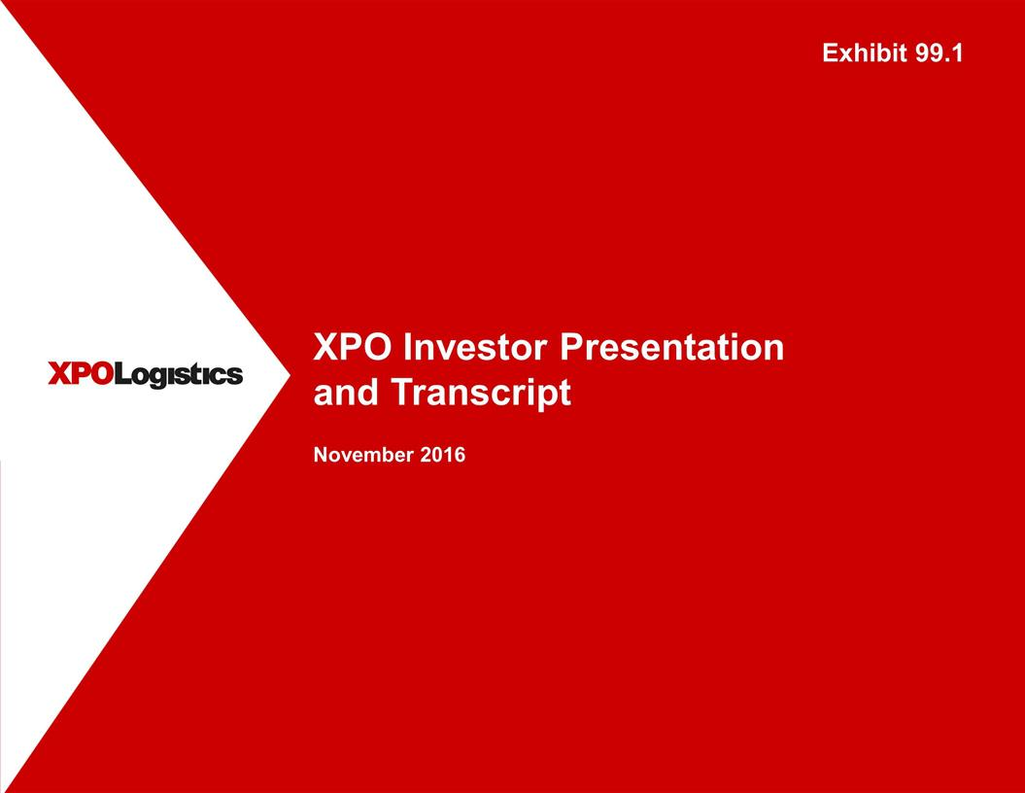

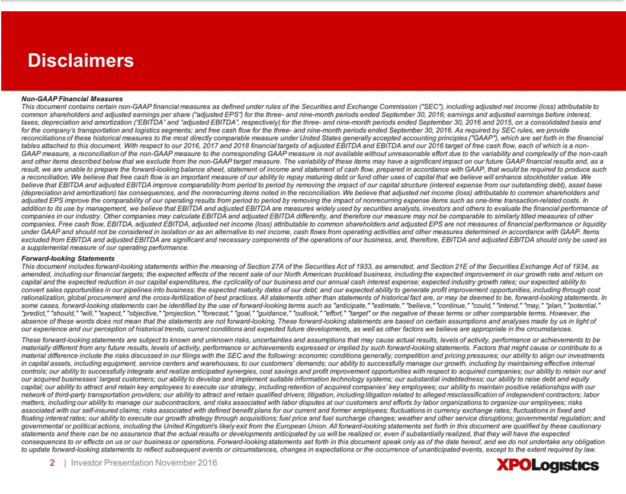

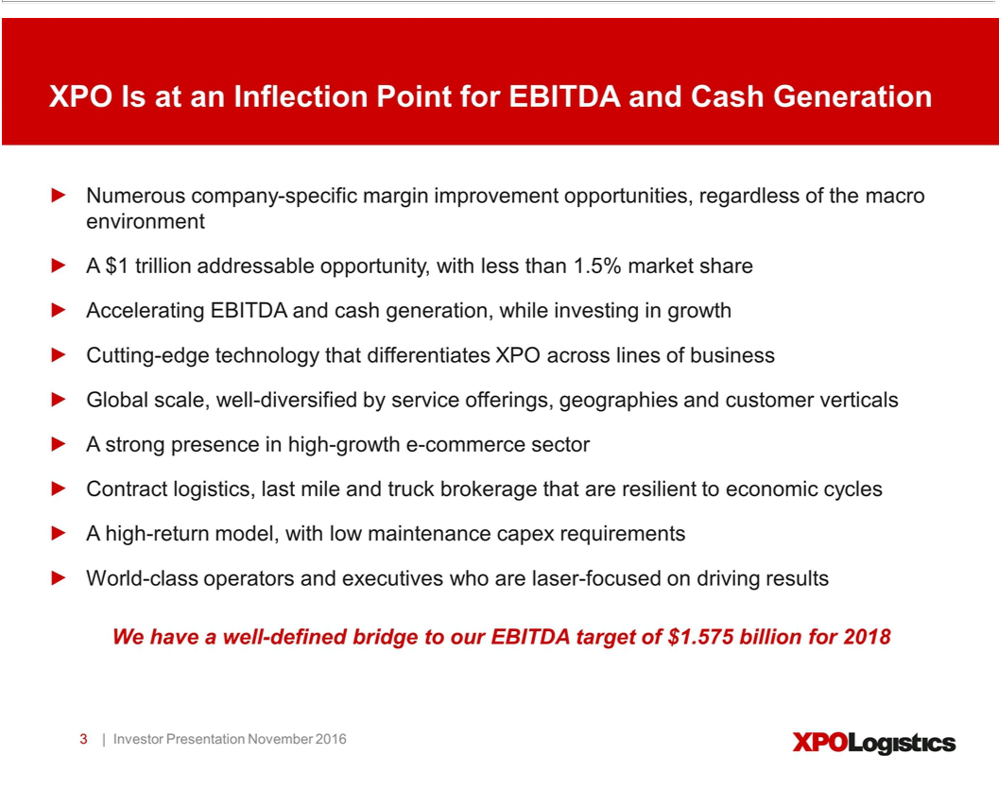

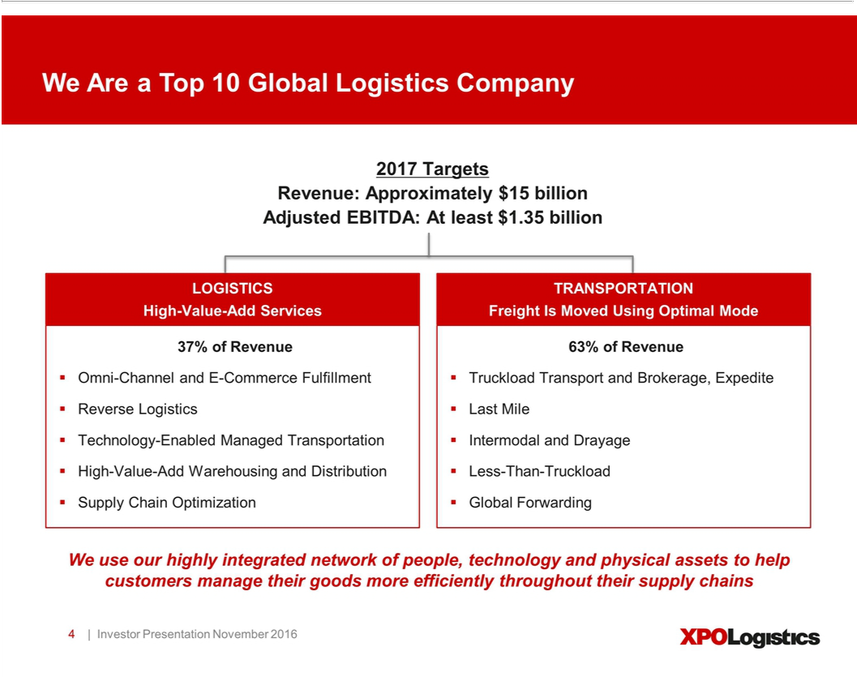

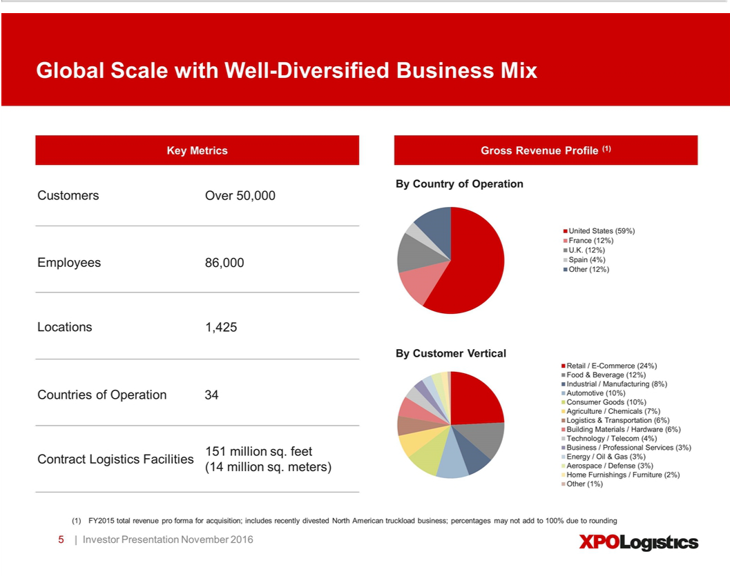

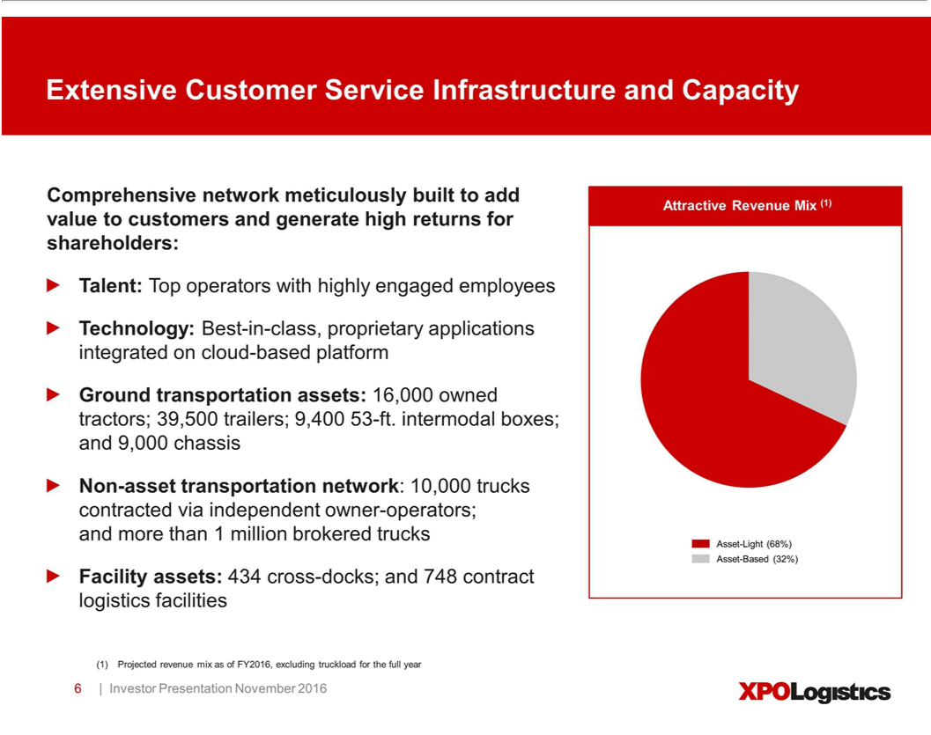

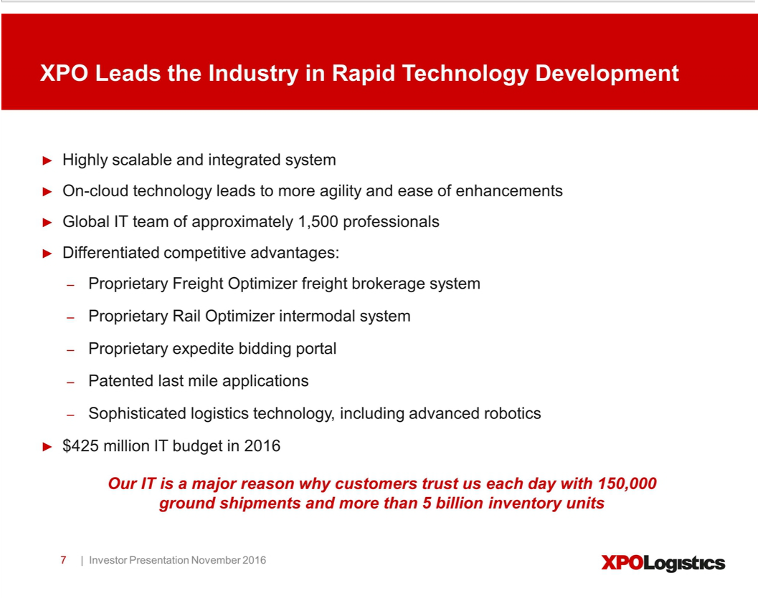

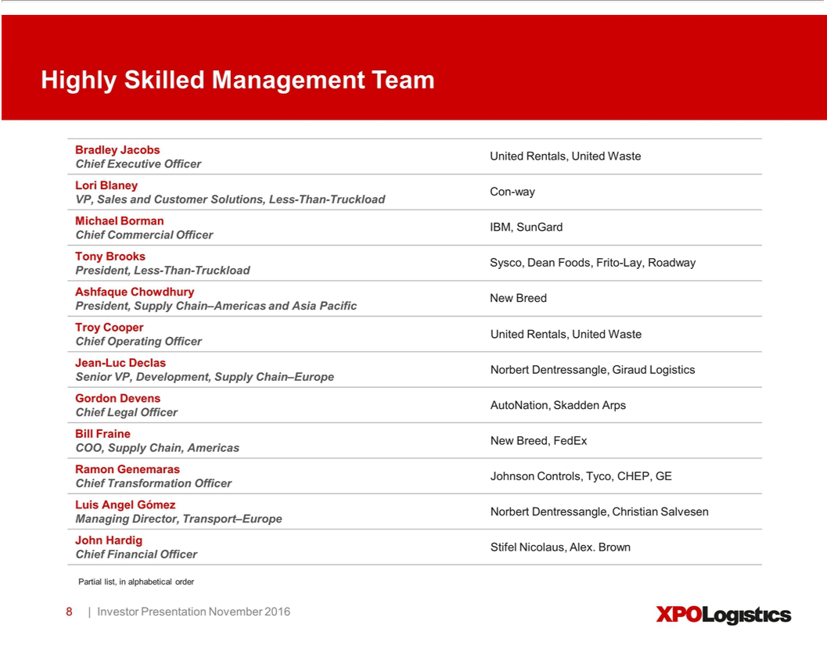

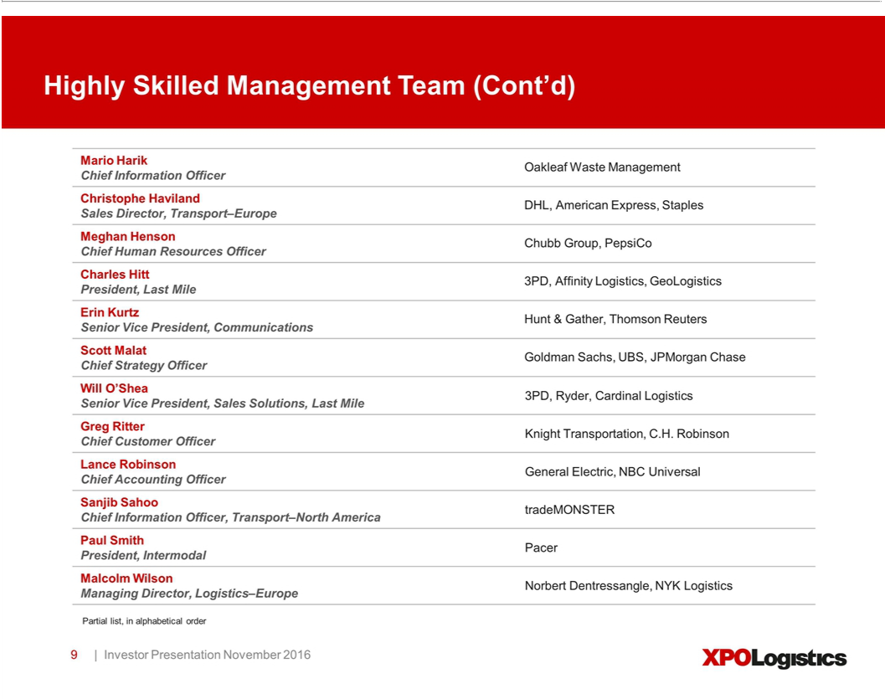

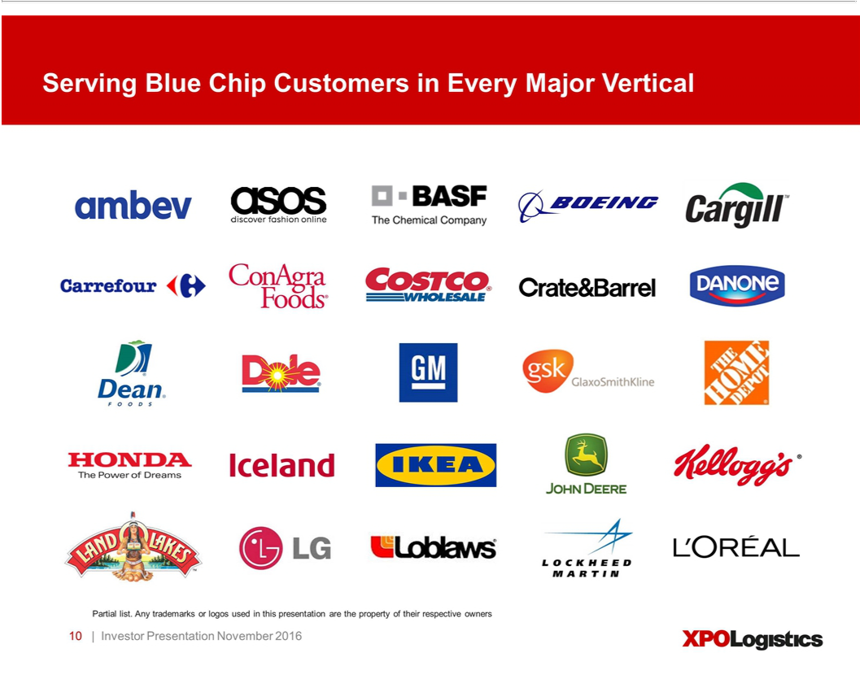

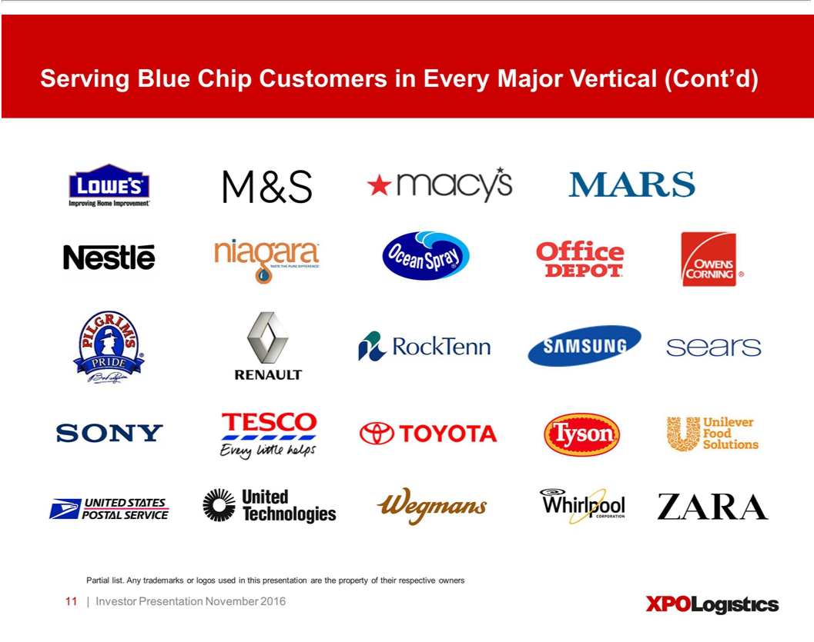

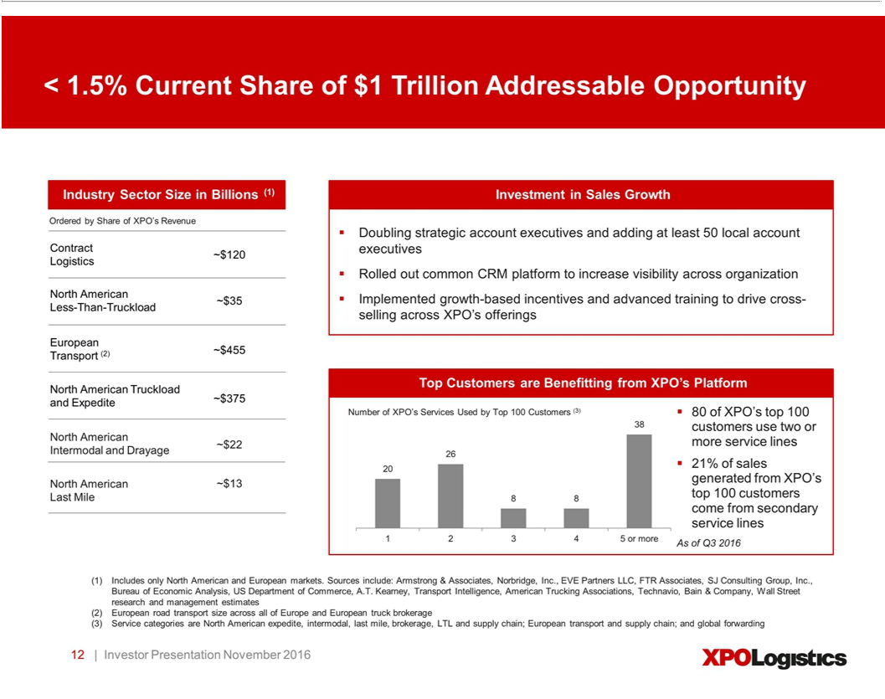

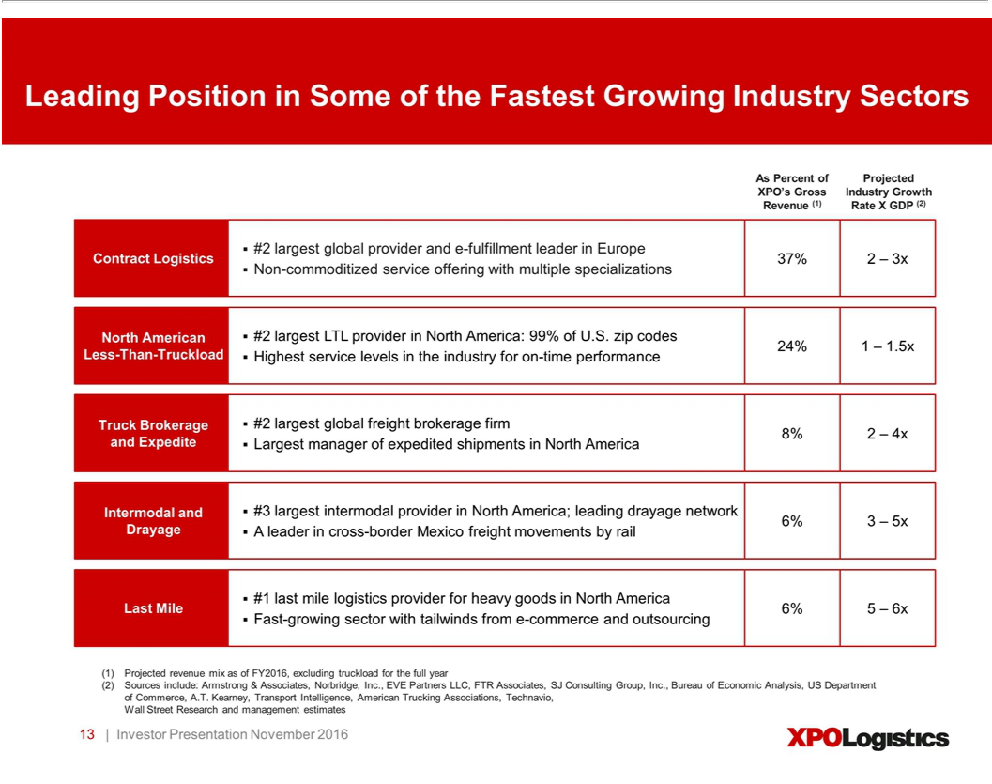

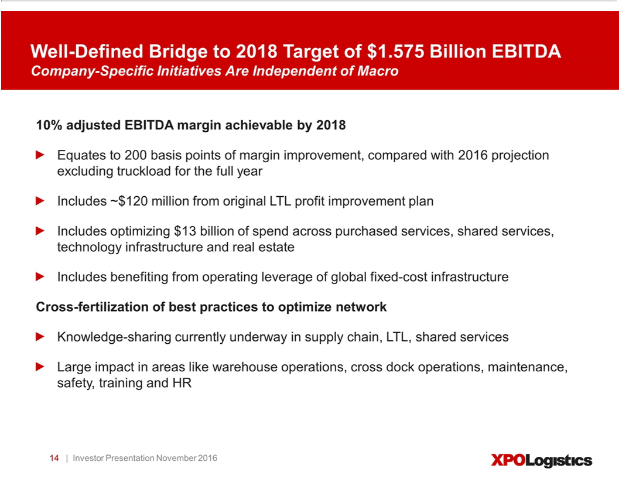

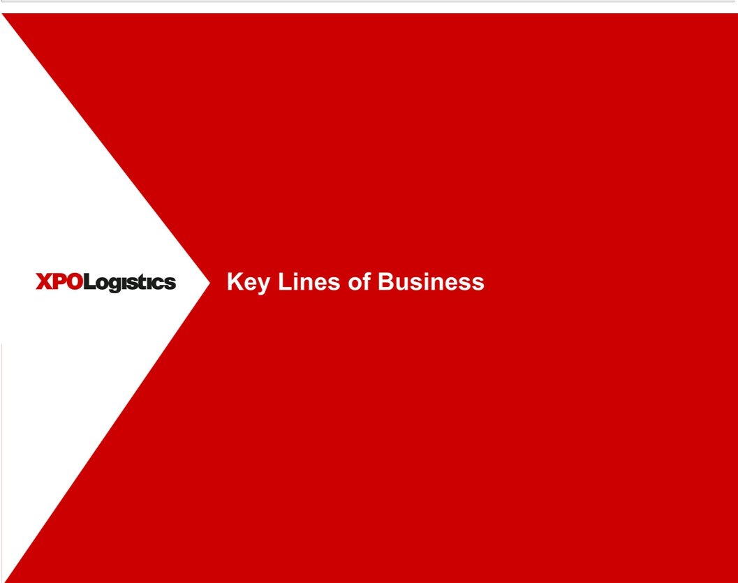

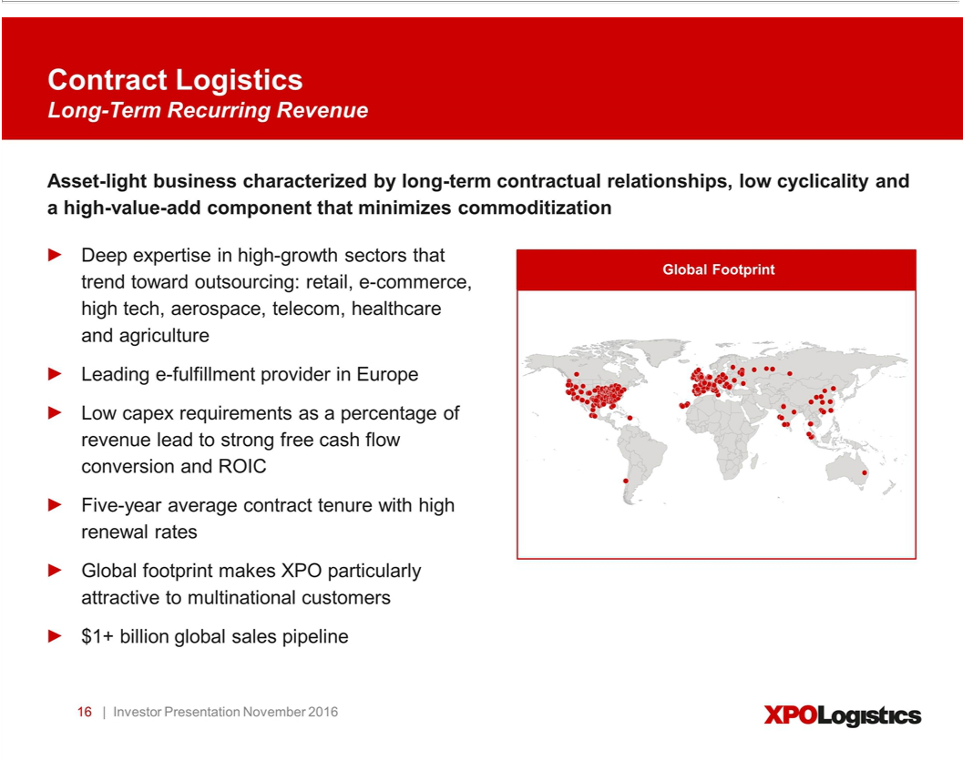

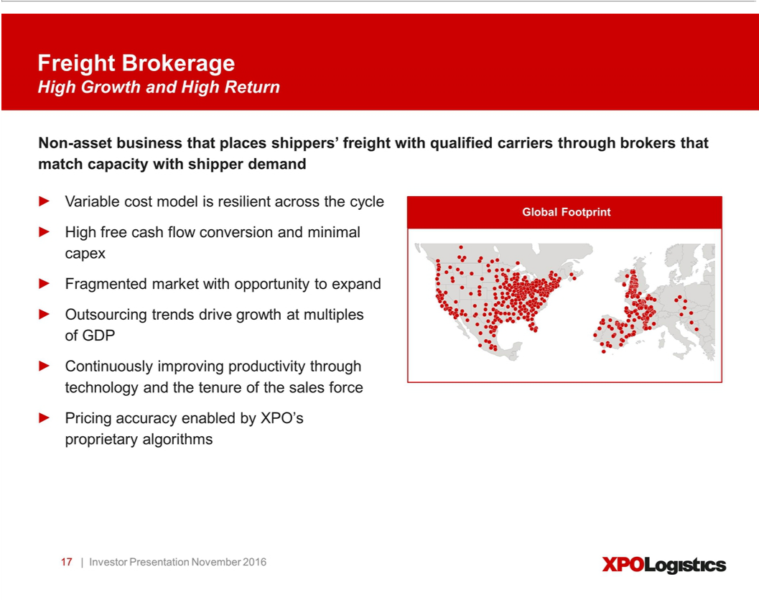

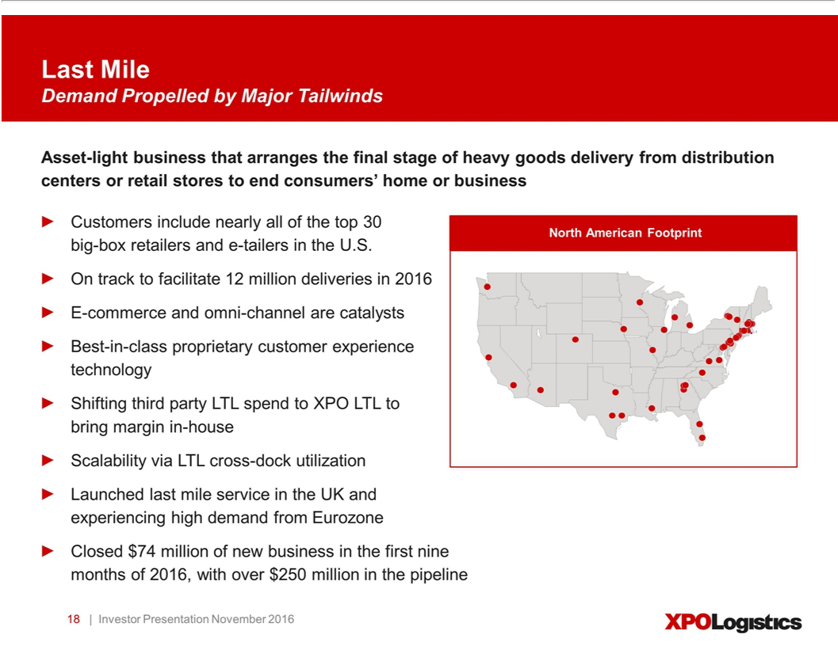

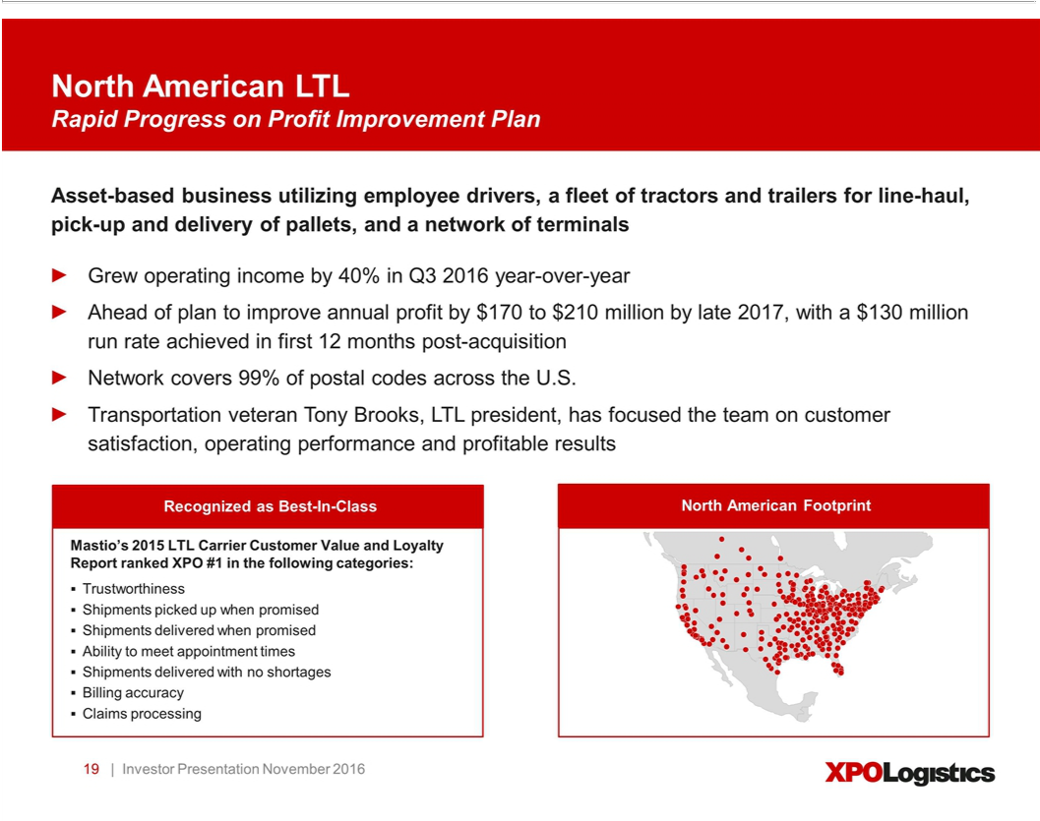

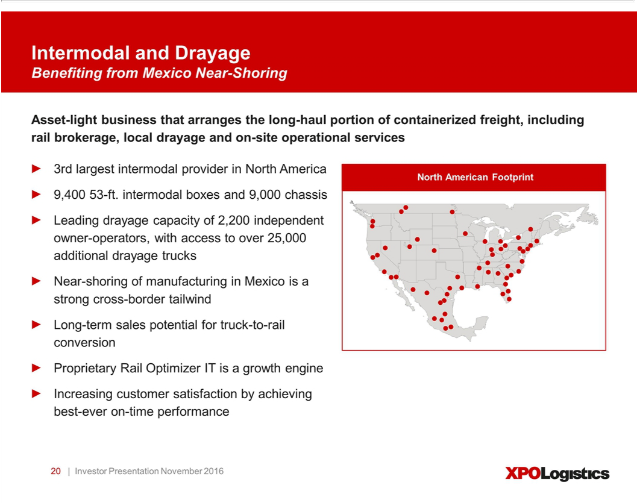

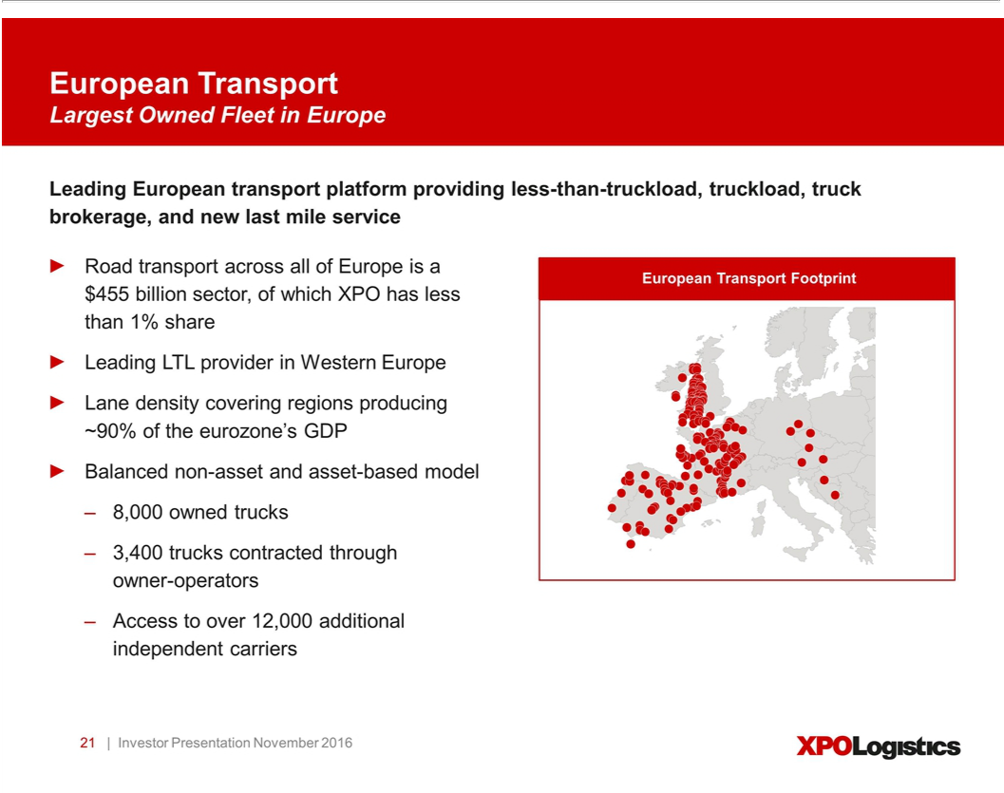

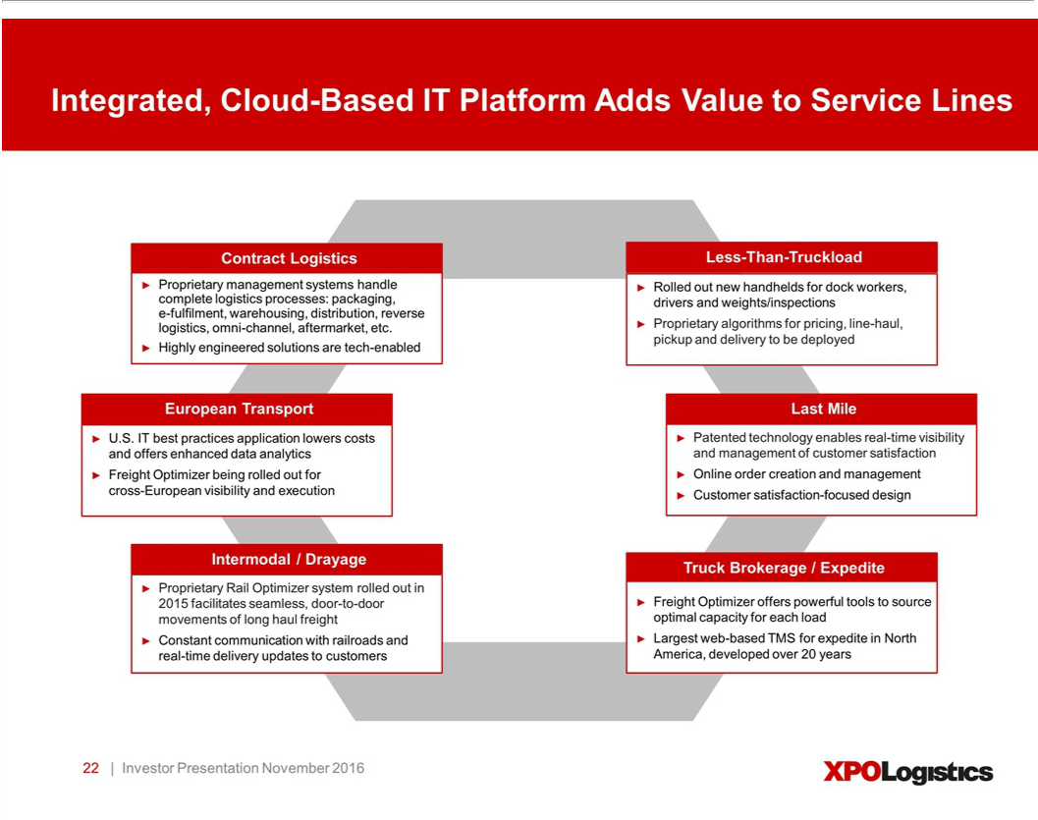

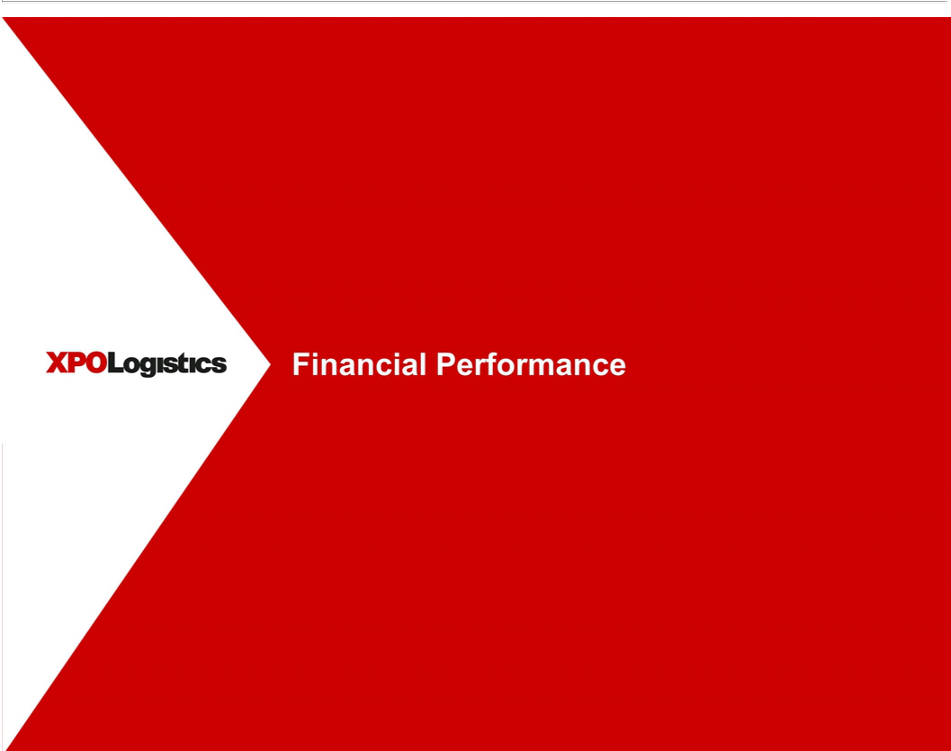

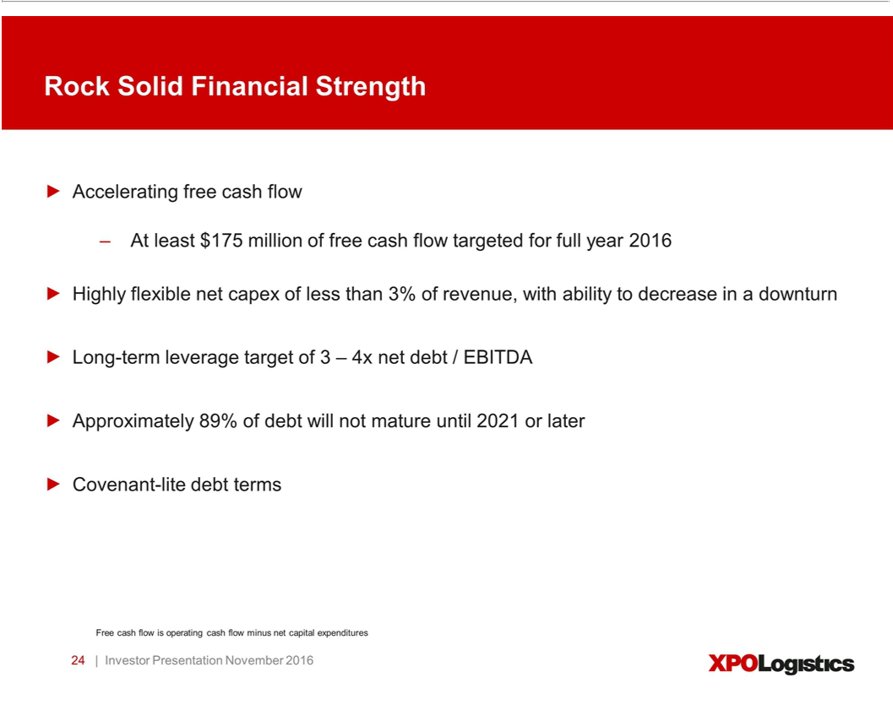

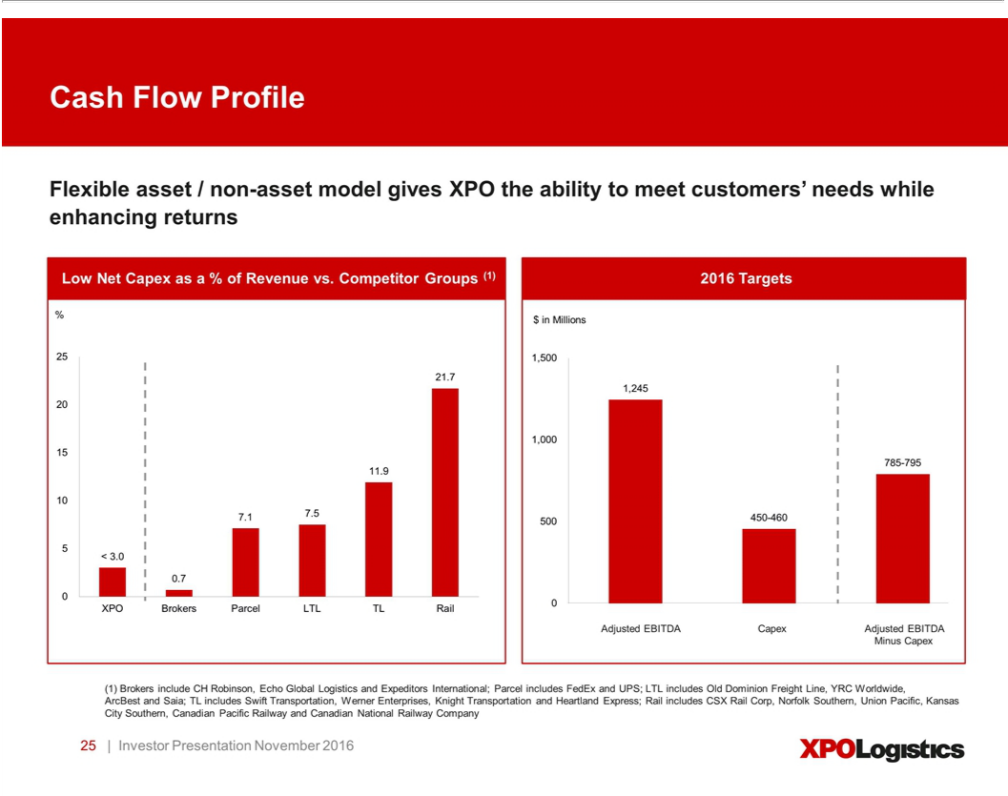

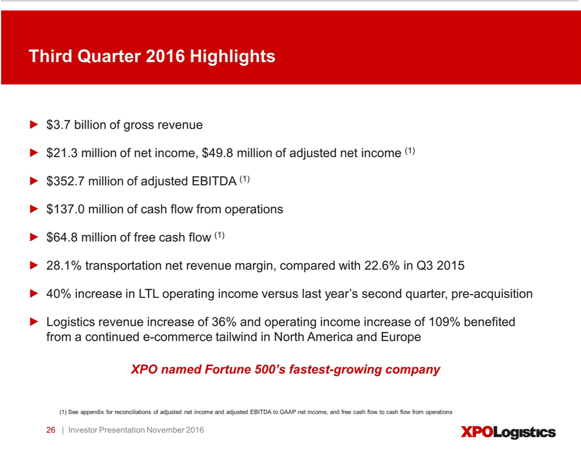

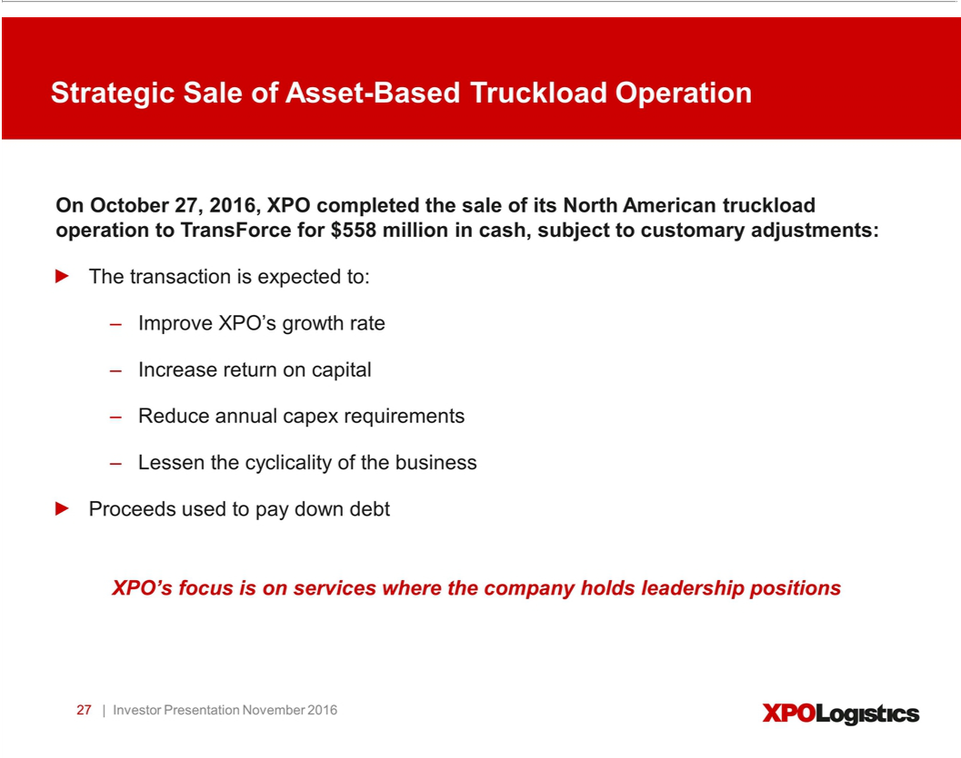

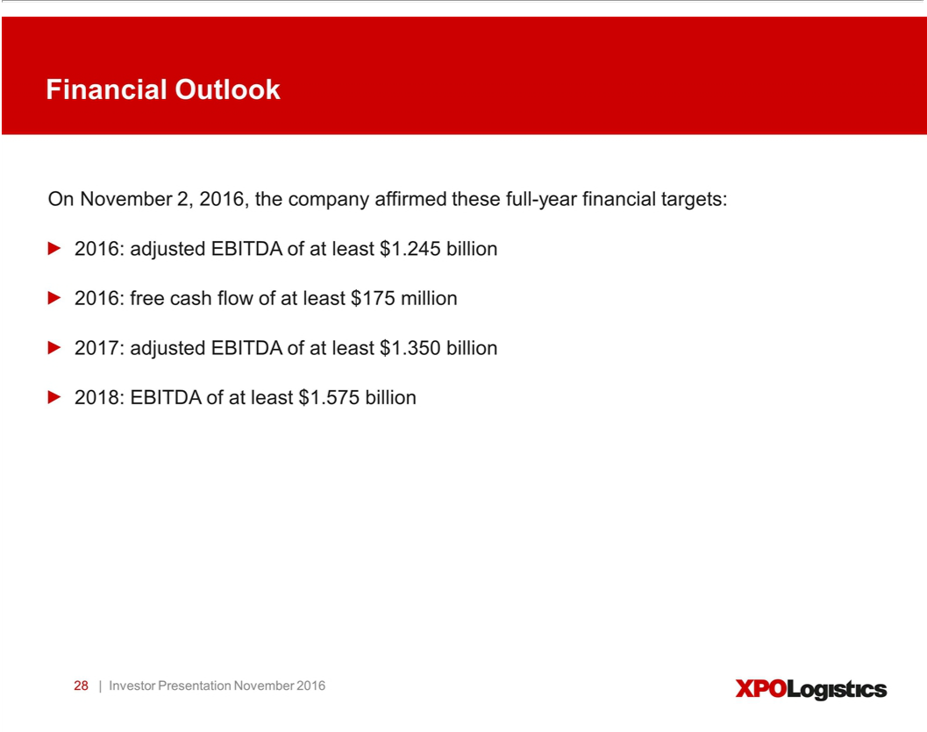

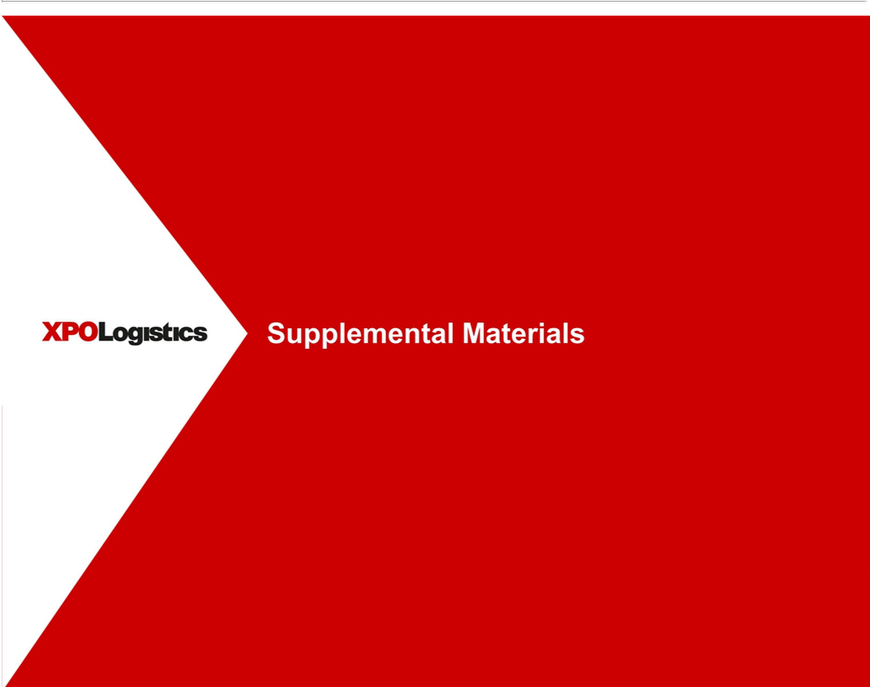

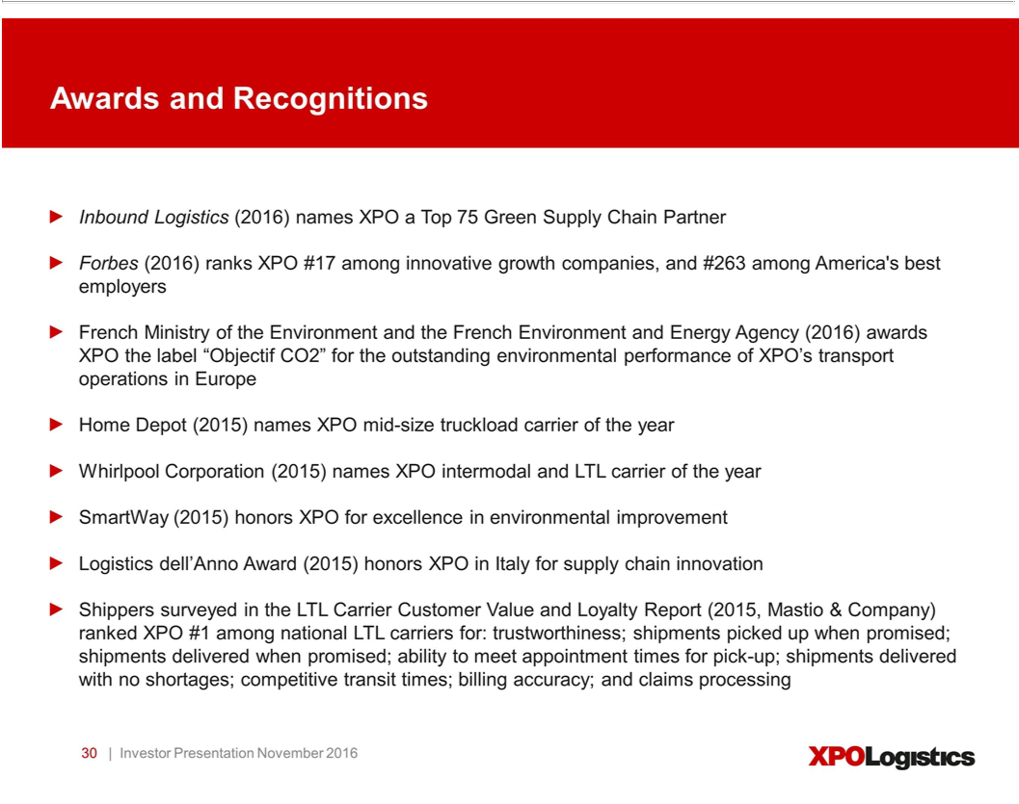

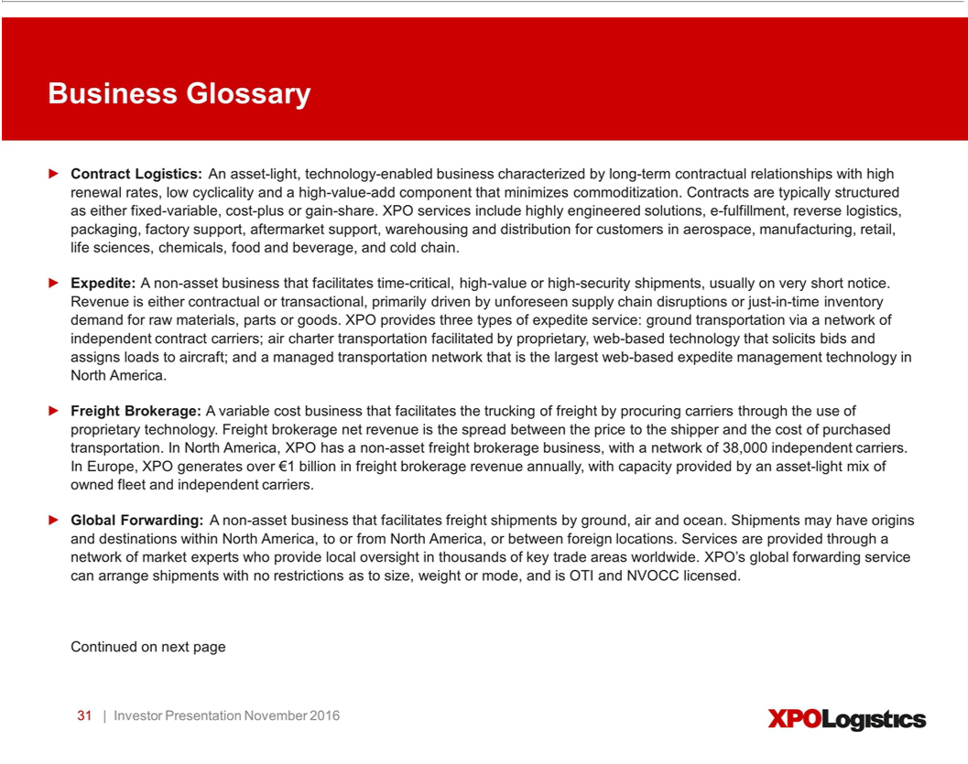

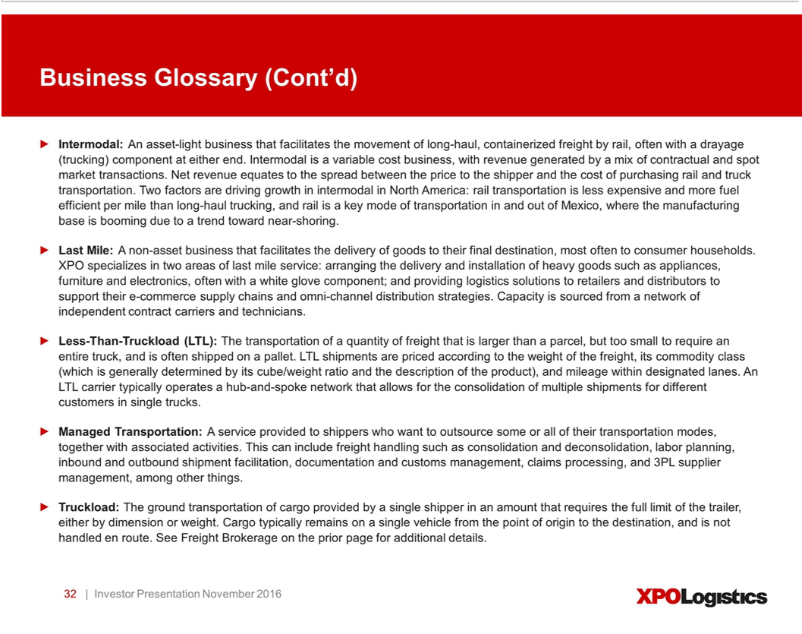

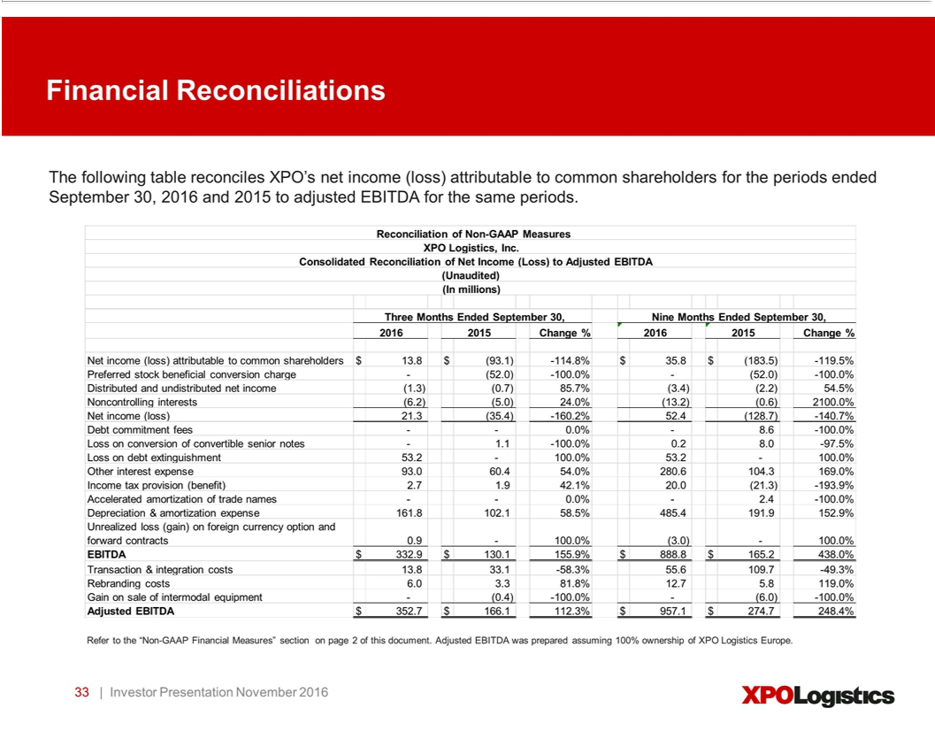

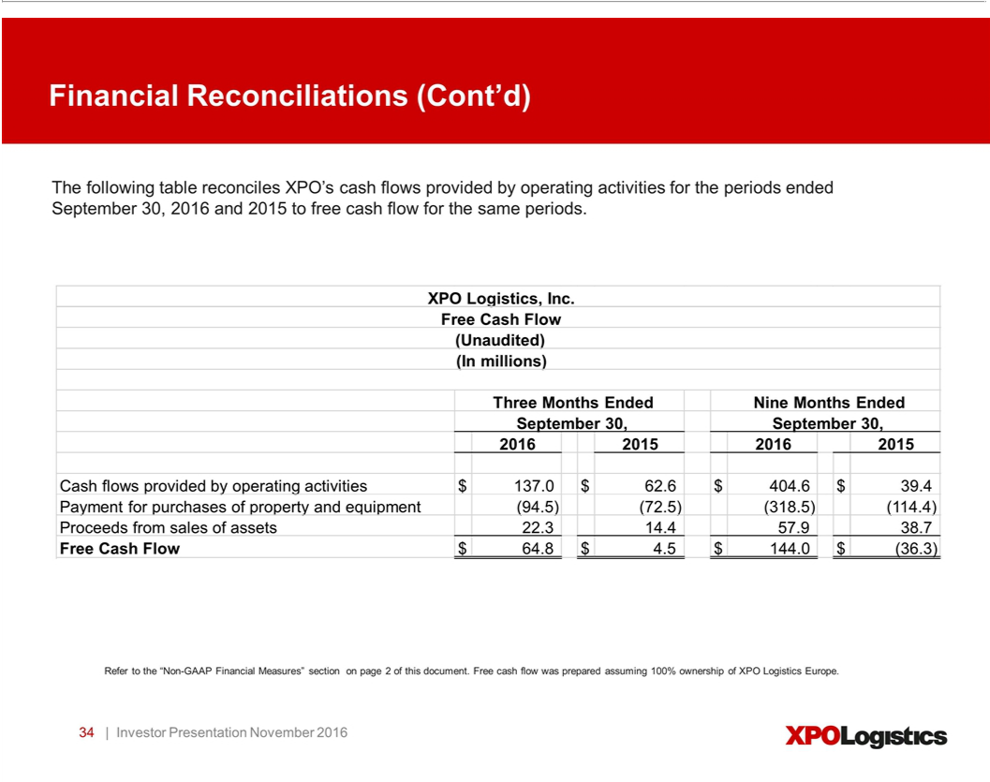

Exhibit 99.2


November 2, 2016

Presentation Script

The following script should be read in conjunction with the accompanying slide presentation, which contains, among other information, source data for certain information set forth in the script.

Thank you for joining us. We’ll start with an overview of XPO Logistics today – our scale, our value propositions for customers and investors, and the dynamics that have brought XPO to a positive inflection point in the evolution of our business. Then we’ll discuss our service offerings in depth. And we’ll summarize our third quarter financial results.

XPO is a top ten global logistics company, with over $14 billion of revenue. This year, we expect to generate at least $1.245 billion of adjusted EBITDA and $175 million of free cash flow. Our 2017 target is at least $1.350 billion of adjusted EBITDA, reflecting a 17% increase over our 2016 target, after excluding our divested truckload operation for the full year. For 2018, we’re targeting at least $1.575 billion of EBITDA.

There are nine main drivers moving us toward our EBITDA and cash flow targets:

- Numerous company-specific margin improvement opportunities, regardless of the macro environment;

- A $1 trillion addressable opportunity, with less than 1.5% market share;

- Accelerating EBITDA and cash generation, while we’re continuing to invest in growth;

- Cutting-edge technology that differentiates XPO across lines of business;

- Global scale, well-diversified by service offerings, geographies and customer verticals;

- A strong presence in the high-growth e-commerce sector;

- Contract logistics, last mile and truck brokerage operations that are resilient to economic cycles;

- A high-return model, with low maintenance capex requirements; and

- World-class operators and executives who are laser-focused on driving results.

Let’s look at each of these points more closely in terms of how they relate to our EBITDA bridge.

We have a well-defined plan to achieve our EBITDA target of $1.575 billion for 2018, including a 10% adjusted EBITDA margin that year. This margin improvement of approximately 200 basis points will come largely from company-specific actions that are independent of macro conditions.

We’ve looked at our operations from every angle in terms of global procurement and operational excellence. Some of the larger opportunities are in the categories of centralized procurement, technology infrastructure, real estate savings, facilities management and other efficiencies.

In addition, we have a major opportunity to increase our profitability through the cross-fertilization of best practices. This is already paying dividends, given the high caliber of our operations on both sides of the Atlantic. We’re sharing knowledge across all service offerings and geographies, with an emphasis on large-impact areas such as customer service, sales, safety, warehouse operations, cross-dock operations, maintenance, training and HR.

The other component of EBITDA growth is revenue. We’re making sizable investments in our sales force to serve our existing customers more completely and provide more support to their supply chains. We’ve nearly doubled the number of strategic account executives in recent months, and have substantially grown our account executive organizations in North America and Europe. In addition, we’ve established growth-based incentives and gained a more holistic understanding of customer needs through our global CRM system.

Now that we’ve reached a key inflection point in the evolution of our business, our cash generation is accelerating significantly. We have a flexible asset/non-asset model that gives us the ability to meet customers’ needs while enhancing return on capital and cash flow. We’ll expand on these and other points in the company section of this presentation.

Business Update

Here’s a snapshot of some recent business developments at XPO:

On October 27, 2016, we completed the strategic sale of our asset-based truckload operation in North America, the former Con-way Truckload. We had bought the truckload business a year ago as part of a package deal in the Con-way acquisition. We sold it for approximately $558 million in cash, subject to customary adjustments.

The divestment furthered our strategy of focusing on the supply chain services where we hold leadership positions: contract logistics, truck brokerage, less-than-truckload, last mile, intermodal, drayage, expedite and managed transportation. In addition, we expect it to improve our return on capital, enhance our long-term growth rate, reduce our capex requirement, and lessen the cyclicality of our business. As the 19th largest U.S. truckload carrier, the operation lacked the scale we look for in our growth strategy.

We used the proceeds from the truckload sale to repay $550 million of debt, resulting in an annual cash interest savings of approximately $23 million. This followed our opportunistic refinancing of $2.6 billion of debt on August 25, 2016, which resulted in expected annual cash savings of approximately $40 million. In total, we reduced our expected cash interest expense by approximately $63 million a year.

We continue to provide our customers with full truckload services through our extensive truck brokerage network, which is the second largest in the world. In North America, our network includes approximately 38,000 independent carriers representing over a million trucks.

Brokerage is a service that’s gaining us share with our existing customer base, driven by a mix of outsourcing, supplier consolidation and cross-selling. As one example, our largest brokerage customer in the last holiday season didn’t use us at all for brokerage 12 months earlier; we cross-sold brokerage to that company through our logistics business. Most customers in our other lines of business need truckload service.

2

Our last mile operation is also taking share, and margins are expanding. Last mile is a service that benefits from e-commerce, which is predicted to grow globally at 13% to 19% through at least 2018. Given the projected demand for e-fulfillment, and our foothold along the e-commerce supply chain, this represents tremendous growth potential. We closed $74 million of new business in the first nine months of 2016, with over $250 million in the pipeline.

Our LTL business is exceeding expectations. In the third quarter, we grew operating income in LTL by a remarkable 40% over third quarter last year, which was pre-acquisition. Our head of LTL is transportation veteran Tony Brooks. Tony has instilled a culture of accountability that has the team focused on customer satisfaction and profitable growth.

We’re ahead of plan to improve annual profit in LTL by $170 million to $210 million by late 2017. At the 12-month mark post-acquisition, we’ve already achieved a profit improvement run rate of $130 million and raised our customer service levels. Line-haul productivity has improved, and we’re heavily investing in technology. We’re rolling out workload planning tools that will drive productivity in pickup and delivery operations by assigning freight to drivers in a more analytical way. We’re implementing new pricing analytics algorithms. And we’re developing engineered standards, customized for each service center, to improve dock productivity. We’ve also added salespeople and strategic account managers, to address the wide-open opportunity to sell LTL to our full customer base in North America.

In logistics, we’ve steadily added vertical expertise, salespeople, CRM capabilities, and resources such as engineering. Our customers are selecting us because we’re developing customized solutions with our advanced technology.

The large, multi-year contracts we signed in 2015 and early 2016 will continue to drive revenue growth through year-end into 2017, and in some cases, for years forward. These include agreements with premier customers such as Heineken, Iceland and Renault.

We’re working with a billion-dollar pipeline of active logistics bids on both sides of the Atlantic, and we expect to accelerate growth in 2017 and again in 2018. There’s high demand e-fulfillment, where we’re the leader in Western Europe. In North America, our logistics team has traction in new verticals where we established credibility by building out our global logistics network in 2015.

Cutting-Edge Technology

XPO empowers its employees to deliver world-class service through information technology, a pillar of our strategy. We place massive importance on innovation, because we believe that technology – in the hands of well-trained, outstanding employees – is the ultimate differentiator in our industry. We have a global team of approximately 1,500 IT professionals who understand how to drive innovation for the benefit of our customers.

We’ll invest approximately $425 million in our IT in 2017, and we’re happy to make that investment. Technology is a huge differentiator for us. We’ve built a highly scalable and integrated system using cloud-based technology that gives us agility and facilitates enhancements. This enables rapid technology development, testing and deployment. We see the ongoing enhancement of our technology as being critical to continually improving customer service and leveraging our scale.

3

Our commitment to technology is pervasive across the company. We’re constantly enhancing our Freight Optimizer and Rail Optimizer systems. On the contract logistics side, the warehouses we run are becoming high-tech hubs, with a combination of automated systems and robotics. It’s leading to important new efficiencies for customers – for example, the ability to customize products on the fly, very close to fulfillment. Our proprietary technology facilitates omni-channel distribution, reverse logistics, lean manufacturing support, aftermarket support, supply chain optimization and transportation management.

In our last mile business, we hold the patents on industry-leading software for real-time workflow visibility and customer experience management. This gives us a competitive advantage in the last mile space, because it documents our ability to deliver superior end-customer satisfaction ratings. We can move quickly to address any sub-par carrier performance.

Company Overview

XPO is a highly integrated network of people, technology and physical assets. We use our network to help customers manage their goods more efficiently throughout their supply chains.

As context, we have two reporting segments: transportation and logistics. We sometimes refer to our logistics operations as “supply chain” or “contract logistics.” We run our business under the single brand of XPO Logistics.

We’re not reliant on the economy of any one country, region or industry. About 59% of our revenue is generated in the United States, 12% comes from France and 12% from the UK. Of the balance, Spain is the next largest at 4% of revenue. In total, we operate in 34 countries, with over 86,000 employees and 1,425 locations.

Our customer base is also highly diversified. The more than 50,000 customers we serve are in every major industry and have thousands of different end markets. Retail and e-commerce accounts for the largest portion of our revenue at 24%, followed by food and beverage at 12%.

Adjusting for the sale of truckload, about 63% of our revenue comes from transportation, and the other 37% is logistics. We’re the second largest provider of contract logistics services globally, which puts us at the forefront of this $120 billion sector that’s projected to grow at two to three times GDP.

Our service range also includes leading positions in four other sectors. Truck brokerage operates within a for-hire truckload market of approximately $375 billion in North America. We’re the second largest broker of truckload freight worldwide, and the largest manager of expedited shipments in North America. Expedite is a type of truck brokerage for urgent freight, and includes e-commerce home deliveries that are larger than parcel in major metro areas. Another area is less-than-truckload (LTL) transportation in North America, a $35 billion sector where we’re the second largest provider.

There’s also intermodal/drayage, a $22 billion opportunity in North America where we’re the number three provider. This puts us in a strong position to capitalize on truck-to-rail conversions. Last mile logistics is a $13 billion sector in the United States, where we’re the largest provider in the heavy goods space, which is growing at five to six times GDP.

4

Together with the $455 billion European transport industry, where we offer less-than-truckload, truckload, truck brokerage and last mile, we’re looking at a total addressable opportunity of $1 trillion or more.

Earlier, we mentioned that XPO functions as a single global network. We’ve meticulously built this network to provide exceptional value for our customers while generating high returns for our shareholders. The components are:

- An intense customer service culture and a highly engaged employee base;

- Best-in-class, proprietary technology integrated on a cloud-based platform across all business offerings;

- Ground transportation assets of 16,000 owned tractors; 39,500 trailers; 9,400 53-ft. intermodal boxes; and 9,000 chassis;

- A non-asset transportation network of 10,000 trucks contracted via independent owner-operators, and more than 1 million brokered trucks; and

- 434 cross-docks and 748 contract logistics facilities.

Our company overall is asset-light, with assets accounting for just under a third of our revenue. Our estimated net capex is less than 3% of revenue.

With that in mind, let’s take a deeper look into XPO, starting with our logistics segment.

Logistics is an asset-light business characterized by long-term contractual relationships, low cyclicality and a high-value-add component that minimizes commoditization. It has low capex requirements as a percentage of revenue, which leads to strong free cash flow conversion and ROIC.

We operate approximately 151 million square feet (14 million square meters) of facility space devoted to our contract logistics operations, with about 65 million square feet (6 million square meters) of that capacity in the United States. Our global footprint makes XPO particularly attractive to multinational customers. Once we secure a contract, the average tenure is approximately five years, and these relationships can lead to a wider use of our services, such as inbound and outbound logistics.

Our supply chain teams provide a range of services to customers, including highly engineered solutions and high-value-add contract logistics. We perform e-commerce fulfillment, reverse logistics, factory and aftermarket support, packaging and labeling, distribution and managed transportation. We also collaborate with our larger customers to optimize their production flows.

Our logistics customers are the preeminent names in aerospace, technology, manufacturing, retail and e-tail, life sciences, wireless, chemical, healthcare, cold chain and other industries where outsourcing is taking root. Cold-chain logistics is a specialty of ours – it involves the handling of critical-care commodities such as food and beverages, which are less sensitive to economic cycles. These products are often highly regulated, with complex logistics requirements.

One of the most attractive parts of our contract logistics range is e-fulfillment. We’re the largest e-fulfillment provider in Europe, with many e-commerce customers that are household names. We also have a major platform for e-commerce logistics in North America, where we provide

5

highly customized solutions for retailers and manufacturers, including reverse logistics and omni-channel services. Our other segment – transportation – includes our businesses for LTL, truck brokerage, last mile, intermodal, drayage, expedite and global forwarding.

We utilize a blended transportation model of brokered, owned and contracted capacity in North America and Europe. Our owned assets benefit our company and our customers, especially during periods of tight capacity, while the non-asset portion of our model is variable cost and gives us extensive flexibility. This “asset right” model serves our customers more consistently in all market conditions and further differentiates our value proposition.

Our truck brokerage line is high growth and high return. It’s a non-asset business that places freight with qualified carriers through brokers that match capacity with shipper demand. Reliable and long-term access to truck capacity is critically important to shippers, and could become even more of a priority if the driver shortage worsens or more regulatory constraints are imposed in the coming years. Our brokerage network of about a million independent trucks in North America resonates with customers who need consistent, reliable truckload service.

Brokerage is compelling to us for a number of other reasons: it uses a variable cost model and is resilient across the cycle. It has high free cash flow conversion and minimal capex. We’ve been continuously improving the productivity of this business through technology and the tenure of our sales reps, as well as ongoing enhancement of our Freight Optimizer technology. Freight Optimizer drives our brokerage operations in North America, and we’re currently rolling it out in Europe.

Brokerage is part of a global ground transportation industry that’s both fragmented and diverse. It’s a $3 billion business for us worldwide. This includes Europe, where we generate over €1 billion of brokerage business annually – a tiny fraction of the addressable opportunity. We have experienced teams on both sides of the Atlantic facilitating industrial flows of raw materials and finished goods, consumer goods, sensitive freight, and freight that is high-value or high-security.

Last mile logistics is an asset-light business that’s being propelled by major tailwinds, primarily from e-commerce and outsourcing. It’s an outsized performer in our service range. We’re the number one provider of logistics services for the home delivery of heavy goods in the U.S. – but we hold less than 7% share.

XPO is the main outsourced provider for the last mile of heavy goods for nearly all of the top 30 big-box retailers in North America. We’re on track to facilitate over 12 million last mile deliveries this year. Our contract carriers often take the goods inside the home, where they perform white glove services such as assembly and installation.

In North America, we’re achieving greater scalability in last mile by multi-purposing our LTL cross-docks. In Europe, which is another fragmented landscape with many regional providers, there’s a large opportunity for us to apply our technology and best practices. We’ve just started exporting our last mile expertise overseas.

Moving on to our LTL business, this is a home run in both North America and Europe. LTL is an asset-based business that utilizes employee drivers, a fleet of tractors and trailers for line-haul, pick-up and delivery of pallets, and a network of terminals. We’re the second largest U.S. provider, covering about 99% of all zip codes; and we offer more next-day and two-day lanes than any other LTL network. We’re also the leading LTL provider in Western Europe, where the service is known as “palletized.” We provide this service in regions that produce approximately 90% of the eurozone’s GDP.

6

In 2016, in our U.S. operations, our LTL on-time pickup is up year-over-year, on-time delivery is up, line-haul productivity is up, and our damages and claims are down. That’s saying a lot, because we had a high bar to surpass. The 2015 Mastio LTL Carrier Customer Value and Loyalty Report found that shippers ranked our LTL business number one among national LTL carriers in the categories of:

- Trustworthiness;

- Shipments picked up when promised;

- Shipments delivered when promised;

- Ability to meet appointment times for pick-up;

- Shipments delivered with no shortages;

- Competitive transit times;

- Billing accuracy; and

- Claims processing.

Intermodal and drayage is an additional growth opportunity for us in North America. Both are asset-light businesses that are involved in the long-haul portion of containerized freight, including rail brokerage, local drayage by independent trucking contractors, and on-site operational services. XPO has one of the largest drayage networks in the U.S., with about 2,200 independent owner-operators and access to another 25,000 drayage trucks.

Despite a sluggish intermodal environment, due to low fuel prices and loose truck capacity, we’ve been able to increase our bidding activity and our sales trends have been improving. Our proprietary Rail Optimizer technology is a growth engine and a differentiator – it was recently instrumental in helping us achieve our best-ever intermodal on-time performance. This improved customer satisfaction, and our on-time performance is now at a record high. We’ve also taken a lot of unnecessary costs out of the network.

The near-shoring trend of manufacturing in Mexico has been a boon to intermodal. It’s driving up the volume of cross-border freight. For companies with North American trade interests, Mexico’s competitively priced labor force and greater speed-to-market measure up favorably against overseas alternatives such as China. In addition, the railroads and the Mexican government have invested heavily in transportation infrastructure, attracting billions of dollars in new plant construction by global manufacturers.

We have a 30-year history in Mexico, and deep relationships with the railroads. We’re on the front lines of near-shoring production for automotive, industrial goods, machinery and consumer goods. Even at the current level of cross-border activity, it’s estimated that there are approximately 2.8 million truck movements across the U.S.-Mexico border each year, so there’s considerable potential for us to convert truck to rail.

We’re also the largest provider of expedited transportation in North America. Expedite shipments are time-critical goods or raw materials that have to get somewhere very quickly, typically on very little notice. One secular driver of expedite demand is the trend toward just-in-time urgent shipments (JIT).

7

JIT is a supply chain strategy that requires 3PL support for both manufacturing production and inventory management. As the largest manager of expedited shipments in North America, we have the resources to respond and pivot very quickly. We have a network of contracted owner operators who handle ground transportation; an automated air charter logistics service that assigns loads through an electronic bid platform; and managed transportation, where our technology initiates a new auction on the internet every 12 minutes. Expedite carriers bid on freight, and we take a fair markup for facilitating the entire process.

Not only does our expedite team serve customers with time-critical needs; they serve our other businesses as well. For example, if a rail track repair stalls a container into Mexico, we can put those goods on a chartered aircraft, or off-load them to an expedite ground carrier in our network. Our ability to find solutions to almost any challenge – often saving our customers from disastrous monetary loss – is a major advantage of our integrated organization.

Another component of our transportation segment is global forwarding, a non-asset business. Global forwarding is a $150 billion sector where customers depend on our domestic, cross-border and international expertise.

The shipments we forward may have origins and destinations within the same country, or move between countries or continents. They may travel by ground, air, ocean, or some combination of these modes. XPO has a network of independent market experts who provide local oversight in thousands of key trade areas worldwide, and we hold OTI and NVOCC licenses. We believe that we can use our growing volume to purchase transportation more effectively for our global forwarding customers.

And finally, we’re a top five global provider of managed transportation, with approximately $2.7 billion of freight under management. Managed transportation is a non-asset service provided to shippers who want to outsource some or all of their transportation modes, together with associated activities. This can include freight handling such as consolidation and deconsolidation, labor planning, inbound and outbound shipment facilitation, documentation and customs management, claims processing, and 3PL supplier management, among other things.

More universally, the secular tailwinds in transportation and logistics are very favorable: a large, growing, fragmented industry with underpenetrated market sectors and trends toward outsourcing, specifically with multi-modal providers. Many companies are seeking to consolidate their supply chain relationships. This is particularly true of large companies with multiple end-markets or multinational footprints. It plays directly to our strengths of scale, lane density, service range and technology.

As one, integrated source for multi-modal solutions, we usually can reduce – sometimes very significantly – a customer’s freight spend and inventory holding costs. We have the resources and infrastructure to provide world-class customer service, with the flexibility to adapt quickly as circumstances change. And we have the expertise to optimize supply chains from A to Z, with the technology to inform critical management decisions.

Global Sales and Service

As another part of our strategy, we’re working diligently to increase our share of wallet with our existing customer base, as well as penetrate our high-growth sectors. Our penetration opportunity with large accounts is huge as we add more value to their supply chains with multiple XPO services.

8

Our experience tells us that the common denominator across all areas of transportation and logistics, around the globe, is that customers want results. Our company’s roots are in expedite, dating back more than 25 years, so a do-or-die mindset of meeting customer expectations is embedded in our DNA. Anything less than stellar service is not an option for us.

Transportation customers want on-time pickup and delivery, and contract logistics customers want their goods to flow smoothly through the supply chain process. They want visibility into their flows, accurate documentation and damage-free handling. If a disruption does occur, customers want to know about it right away and they want to see a solution. If you walk into any XPO office or facility, you’ll see that our people are trained to be professional, efficient and on top of things. They understand the importance of communication. And they know what it means to have a zero-fail mentality.

We see an opportunity to continue to differentiate XPO on the basis of phenomenal customer service in each of our lines of business. In every case, the litmus test is our customer. Is the customer thrilled to have chosen XPO? Are we constantly improving on the value we deliver? When we receive awards for operational excellence and performance from world-class companies such as Diebold, Nissan, Navistar and Whirlpool, we know that we’re doing our job.

We also see opportunities to expand our leadership in areas of corporate responsibility, such as environmental awareness. We’re proud to have received several environmental recognitions this year, including being named one of 75 Green Supply Chain Partners by Inbound Logistics. In France, we’ve been awarded the label “Objectif CO2” by the French Ministry of the Environment and the French Environment and Energy Agency – this recognizes the outstanding environmental performance of our transport operations in Europe.

We have several exciting developments going on in Europe right now on the “green” front. For example, in March, we announced a collaborative agreement to set up France’s first urban rail shuttle. This landmark project in urban logistics is designed to provide economical and environmentally responsible service to the heart of Paris. Each Eurorail train shuttle will be able to transport 60 container cars of products. The products will then be distributed on XPO Logistics trucks that use alternative fuels such as natural gas instead of diesel. It will contribute to the reduction of diesel use in Paris for the transportation of merchandise, with fewer trucks on the streets of the city.

XPO is an environmental leader in Spain as well with the launch of government-approved mega-trucks. Mega-trucks use linked trailers that total 25.25 meters (82.84 feet) in length with a payload capacity of 39 tons. These trucks can reduce CO2 emissions by over 25% and can potentially generate cost savings of over 20%.

That sums up our many avenues for value creation. Now it comes down to operational excellence and management. You’ll find some information of interest about our leadership talent at the end of this presentation.

Financial Highlights

We had a very strong third quarter. We generated $353 million of adjusted EBITDA, $137 million of cash flow from operations, and $65 million of free cash flow, all third quarter records for XPO. Our most robust growth came from our last mile and contract logistics operations in North America and our contract logistics operation in Europe. Market conditions were sluggish overall, but e-commerce was a major tailwind – driving margin expansion in our last mile business, and resulting in major contract wins in contract logistics.

9

Our transportation segment improved third quarter net revenue margin to 28.1%, up significantly from 22.6% in the third quarter a year ago. Our logistics segment delivered a 36% increase in revenue, and a 109% increase in operating income.

Approximately 89% of our debt doesn’t mature until 2021 or later, and all of our debt is covenant-light. We’re within our long-term leverage target of three to four times net debt over EBITDA.

On November 2, 2016, we:

- Raised our full-year 2016 free cash flow target to at least $175 million, as compared with the prior target of at least $150 million.

- Issued a full-year 2017 adjusted EBITDA target of at least $1.350 billion. This target reflects a 17% increase over targeted full-year 2016 adjusted EBITDA of $1.150 billion, after excluding the North American truckload operation for the full year.

- And updated the following full-year financial targets:

  - For 2016, at least $1.245 billion of adjusted EBITDA — status quo with the prior target of $1.265 billion, after accounting for a $20 million impact from the truckload divestment.

  - For 2018, at least $1.575 billion of EBITDA — status quo with the prior target of $1.7 billion, after accounting for the truckload divestment.

Inflection Point for Value Creation

So in summary, we’re at an inflection point in the evolution of our business: accelerating our EBITDA and cash generation, while continuing to invest in technology, our sales force and other levers of future growth.

XPO is on the radar in every industry that requires transportation or logistics. Our leading positions in so many parts of the supply chain are clearly resonating with customers. We’re not just selling brokerage or contract logistics or expedite. We’re working closely with customers to look at their entire supply chains, with all modes, from point of origin to the end-consumer, to help our customers operate more efficiently and take out costs. We look at the entire flow of goods, both holistically and in segments, to identify the opportunities. This collaborative approach, paired with our innovative IT, are major reasons why customers trust us with an average of 150,000 shipments and over five billion inventory units every day.

We have a strong franchise in each of our service offerings, with leadership positions in fast-growing areas such as e-fulfillment. We’re well diversified by geographies, by verticals and types of service. Most important, we have top shelf talent – seasoned operators and executives who know how to achieve results.

10

We’re also benefiting from many opportunities that are specific to XPO. These include numerous synergies and cost savings from the two major acquisitions we did last year. We have internal initiatives underway around the world to serve our customers even better, continuously improve our performance, compensate and motivate our people, lower our procurement costs, and expand our global sales efforts. The potential is dramatic: we have a $1 trillion addressable opportunity, of which we hold less than 1.5% share.

This year, we not only made the Fortune 500 list for the first time, we were named the fastest-growing Fortune 500 company. In addition, Forbes ranked us #17 among innovative growth companies, and #263 among America’s best employers. It’s rewarding to get these accolades for what we’ve accomplished to date, and we’re excited to be at a dramatic inflection point for global profitability and cash flow growth.

Thank you for your interest!

Appendix: Leadership Team (Partial List)

Our CEO, Brad Jacobs, has a unique track record in the business world. He‘s started five companies from scratch, including three publicly traded ones, and built each into a billion or multi-billion dollar enterprise. Brad and the management teams he led created dramatic shareholder value. In the process, they acquired and integrated approximately 500 companies and opened about 250 greenfield cold-start locations.

The two most recent companies Brad led prior to XPO were United Waste Systems, which he built into the fifth largest solid waste management company in North America, and United Rentals, which he grew to be the largest construction equipment rental company in the world. From 1992, when Brad took United Waste public, to 1997, when he sold it for $2.5 billion to Waste Management, the earnings grew at about 55% CAGR and the stock price outperformed the S&P 500 by 5.6 times. At United Rentals, over the 10 years he led the company, the stock outperformed the Index by 2.2 times.

Underlying this history is Brad’s ability to assemble world-class management talent to execute a business plan with great discipline. One of our most important competitive advantages at XPO is that we have a leadership team whose collective skill set matches our ambitious strategy. For a competitor to successfully do what we do, it would need to do more than add services – it would need to replicate our deep bench of talent, not only at the senior level, but in every key position. Here are just a few examples:

Lori Blaney is vice president of sales and customer solutions for our less-than-truckload business. She’s responsible for the development and execution of our LTL growth strategy. Lori was with Con-way for more than 20 years before it was acquired by XPO, most recently as vice president of national account sales. Earlier, she served in management positions in sales operations, business development, marketing and human resources.

Michael Borman is our chief commercial officer, with executive responsibility for XPO’s commercial strategy and the operation of our sales organization. His more than three decades of global experience include a notable tenure with IBM, where he led a workforce of 18,000 sales and technical support associates to grow the revenue of the Software Group from $9 billion to $18 billion in four years. Additional roles with IBM included head of the $29 billion business partners organization; P&L responsibility for the $4 billion iSeries (AS/400) server line; management of the UNIX server line; and responsibility for Asia-Pacific and other regional business units. Mike has served in chief executive positions with SunGard Public Sector and legacy operations of Symantec Corporation and Emerson Electric.

11

Tony Brooks leads our less-than-truckload business in North America. He’s a 30-year career transportation and logistics executive who has run three of the largest fleets in North America, and spent 11 years with LTL long-haul carrier Roadway Express. Tony joined XPO from multinational food distributor Sysco, where he was responsible for North American field operations. Prior to Sysco, he served as senior vice president of logistics for Dean Foods, with responsibility for logistics, delivery, warehousing and fleet management. Earlier, over a decade in national operations with Sears, he drove significant cost efficiencies and improved safety performance. For PepsiCo/Frito-Lay, he held executive responsibility for regional transportation, fleet, warehousing and inventory management.

Ashfaque Chowdhury leads our contract logistics business as president of supply chain, Americas and Asia Pacific. Ashfaque joined XPO upon the acquisition of New Breed Logistics, where he spent more than 20 years delivering solutions to complex supply chain requirements. He initially served as XPO’s executive vice president and chief information officer for contract logistics in the Americas, leading the technology services and advanced solutions organizations. Ashfaque has implemented more than 100 logistics operations for some of the most preeminent companies in the world.

Troy Cooper is our chief operating officer and global head of XPO’s two operating segments: transportation and logistics. Troy previously worked with Brad to help build two public companies. As a vice president for United Rentals, he helped integrate over 200 acquisitions in the United States, Canada and Mexico. For United Waste Systems, he helped build an integrated network of 86 truck-based collection companies and 119 facilities in 25 states. Earlier, Troy was with OSI Specialties, Inc. (formerly a division of Union Carbide, Inc.).

Jean-Luc Declas is senior vice president of development for our supply chain business in Europe. He previously served in a similar role with Norbert Dentressangle, which he joined in 2004. Jean-Luc has nearly 20 years of logistics management experience, including five years with multinational Giraud Logistics, where he served first as managing director of Central Europe, and then as managing director of France.

Gordon Devens is our chief legal officer, responsible for all corporate legal matters, governance and compliance. He also serves as the vice chairman of the Supervisory Board of XPO Logistics Europe. Prior to XPO, Gordon was vice president–corporate development with AutoNation, following positions there as associate general counsel and senior counsel for the retail automotive group. Earlier, he was an associate at Skadden, Arps, Slate, Meagher & Flom LLP.

Ramon Genemaras is our chief transformation officer – he leads the ongoing transformation of our global business processes by rationalizing our cost structure and cross-fertilizing best practices. Ramon has nearly three decades of senior experience in operations excellence, network optimization, strategic sourcing management and Lean Six Sigma with Fortune 500 companies. Prior to XPO, he served as chief operating officer for a $4.5 billion division of Johnson Controls; vice president–operational excellence for an $8 billion division of Tyco International; and senior vice president–global operations and supply chain for CHEP, a logistics company of the Brambles Group. Earlier, he spent 17 years with General Electric Company, including executive roles with GE Motors Manufacturing, GE Commercial Transformers and GE Industrial Solutions.

12

Luis Angel Gomez is managing director of XPO’s transport business in Europe. Luis joined XPO with 15 years of transportation expertise, including eight years with Norbert Dentressangle, where he led the Iberian, then global, transport operations, and served on the executive board. His leadership has been key in developing value-added services as part of the company’s international growth strategy for transport, including LTL and palletized cross-border services in Europe and brokerage services. Luis is highly experienced in the dynamics of European markets – he joined ND as managing director of the company’s transport operations in Spain, and grew the business to become a top three geography for ND’s transport network. Prior to ND, Luis held executive positions with transportation companies Christian Salvesen Gerposa and Transportes Gerposa.

John Hardig, our chief financial officer, has been a significant presence in the transportation industry for nearly two decades. Before joining XPO, John was a managing director in the Transportation & Logistics group at Stifel Nicolaus Weisel, and an investment banker in the Transportation and Telecom groups at Alex. Brown and Sons. Over the course of his career, he has completed over 60 M&A transactions and his teams have raised billions of dollars of capital for many of the industry’s leading logistics companies, including IPOs for C.H. Robinson and Hub Group, and follow-ons for Forward Air, Inc., Heartland Express, Inc. and Knight Transportation, Inc.

Mario Harik is our chief information officer. He was previously the CIO at Oakleaf Waste Management, an innovator in logistics for environmental management. Mario has been tapped over the years by Fortune 100 companies for his expertise in building comprehensive IT organizations and proprietary platforms, similar to what we’re doing here at XPO. He’s put together a superstar team that uses technology in innovative ways tied directly to customer service.

Christophe Haviland is head of sales for our transport business in Europe. Christophe has over 25 years of senior business development experience, including 11 years at DHL where he led market penetration efforts in the technology and banking sectors, and was responsible for cross-region global account development in the Americas, Asia-Pacific, Europe, Middle East and Africa. More recently, Christophe served as sales director for large markets and director of multinational accounts at American Express, and was director of business development for Staples in France.

Meghan Henson leads our global human resources organization as chief human resources officer. She has 15 years of senior experience leading domestic and international HR operations. Prior to XPO, Meghan served as CHRO for the Chubb Group of Insurance Companies, with global responsibility for workforce support in 54 countries. Earlier, over eight years with PepsiCo, she held executive roles that included CHRO for global functions; senior vice president of HR for the $10 billion Gatorade, Tropicana and Quaker product businesses; and head of HR in the Greater China Region for PepsiCo’s multi-product direct sales business unit.

Charlie Hitt is responsible for leading our last mile business, following three years as its chief strategy officer. Charlie has more than 30 years of industry experience, including 15 years with Merchants Home Delivery Service (now MXD Group). As director of operations for Merchants, he was instrumental in growing revenue more than six-fold. He subsequently served as senior vice president–domestic operations for GeoLogistics, and as partner and chief operating officer of Affinity Logistics, before joining last mile leader 3PD in 2007. Charlie led 3PD’s operations in executive roles until XPO acquired the business in 2013.

13

Erin Kurtz leads our company’s global communications strategy and implementation. Erin is a seasoned leader with more than 15 years of experience in corporate messaging, public relations, brand marketing and social media. Prior to joining XPO, she co-founded marketing agency Hunt & Gather to create campaigns for global brands. Earlier, she served as vice president of external communications for AOL, was a director with Joele Frank, and led a global public relations team at Thomson Reuters that elevated the Reuters profile around the world.

Scott Malat is our chief strategy officer. Scott is responsible for our company’s strategy and capital structure, as well as analyzing potential acquisition opportunities and managing our technology organization. Prior to joining XPO, he was the senior transportation analyst covering air, rail, trucking and shipping at Goldman Sachs. Earlier he was an analyst with UBS, and served as an internal strategy manager with JPMorgan Chase, where he worked with several of the bank’s business units.

Ludovic Oster is senior vice president of human resources for XPO Logistics Europe. Ludovic joined Norbert Dentressangle in 2008 as head of human resources. In 2015, he was instrumental in the successful integration of ND following its sale to XPO. He is a former member of the Norbert Dentressangle executive board, and previously held positions with Delphi and Valeo.

Grant Richard is senior vice president–global IT infrastructure. Grant has a 20-year track record of transforming IT infrastructure through innovative architecture, operating efficiencies and the integration of global processes. Prior to XPO, he held a similar position with Goldman Sachs, where he was instrumental in the success of numerous technology and management initiatives, including the creation of the firm’s risk and pricing infrastructure. Grant is a prior co-chair of the non-profit Open Computer Project, and has served on the faculty of Columbia University’s professional degree program.

Greg Ritter is chief customer officer, responsible for developing integrated supply chain solutions for some of the largest companies in North America. Greg has more than three decades of sales and management experience in multi-modal transportation logistics. Prior to XPO, he served as president of Knight Brokerage, a subsidiary of one of the top ten transportation logistics providers in North America. Earlier, Greg spent 22 years with C.H. Robinson Worldwide.

Lance Robinson is our chief accounting officer, responsible for the financial strategy, risk management, administration and control systems of our global accounting operations. He has extensive senior financial experience, including 10 years as global controller–mergers and acquisitions for General Electric, and positions as chief accounting officer and vice president of business development for NBC Universal. Earlier, he was senior manager–assurance practice with Arthur Andersen. Lance is a certified public accountant, chartered accountant and chartered global management accountant.

Sanjib Sahoo is chief information officer for transport–North America, with responsibility for the technology groups that support our truck brokerage, intermodal, last mile, expedite and freight forwarding operations. Sanjib Sahoo has an impressive career history of fostering innovation and building world-class IT teams. Prior to XPO, he was CIO at tradeMONSTER (now e*Trade), where he built and led the team that developed a highly regarded options trading platform with significant real-time capabilities and best-of-breed mobility. Sanjib is the architect of numerous other groundbreaking innovations that have driven commercial growth strategies.

14

Maneet Singh is XPO’s senior vice president of IT shared services, with responsibility for the company’s shared services technology infrastructure. Maneet has more than a decade of executive experience in transforming large IT organizations to increase corporate and commercial productivity, reduce costs and enhance revenue growth. His global strategies have led to enterprise-wide adoption of best practices, driving continuous improvement in national and multinational corporations. Prior to XPO, Mr. Singh led the business systems transformation and integration organization for Harris Corporation, and served in senior positions with Emerson Electric Company.

Drew Wilkerson is regional vice president for our brokerage business in North America, with P&L responsibility for 11 freight brokerage offices, including the company’s flagship operations in Charlotte, N.C. and Ann Arbor, Mich. Additionally, Drew serves as key liaison for strategic brokerage customers. He has more than a decade of versatile industry experience, including six years with C.H. Robinson Worldwide, where he held leadership roles related to strategic sales, carrier relationships, customer relationships and operations. Upon joining XPO in 2012, he launched the Charlotte brokerage office and grew it into the largest cold-start operation in the company’s history, with an annual revenue run rate of over $70 million in the first 18 months.

Malcolm Wilson is managing director of XPO’s logistics business in Europe. Malcolm has two decades of international experience in contract logistics management, including eight years with Norbert Dentressangle, where he served in a similar position and was a member of the executive board. Under Malcolm’s leadership, ND’s contract logistics business achieved global scale through a mix of organic growth and the integration of the Christian Salvesen and TDG acquisitions in the United Kingdom. He has been instrumental in developing ND’s global logistics operations into the company’s largest revenue-producing unit. Prior to ND, Malcolm held executive positions with Christian Salvesen, TDG and NYK Logistics.

Non-GAAP Financial Measures

This document contains certain non-GAAP financial measures as defined under rules of the Securities and Exchange Commission (“SEC”), including adjusted net income (loss) attributable to common shareholders and adjusted earnings per share (“adjusted EPS”) for the three- and nine-month periods ended September 30, 2016; earnings and adjusted earnings before interest, taxes, depreciation and amortization (“EBITDA” and “adjusted EBITDA”, respectively) for the three- and nine-month periods ended September 30, 2016 and 2015, on a consolidated basis and for the company’s transportation and logistics segments; and free cash flow for the three- and nine-month periods ended September 30, 2016. As required by SEC rules, we provide reconciliations of these historical measures to the most directly comparable measure under United States generally accepted accounting principles (“GAAP”), which are set forth in the financial tables attached to this document. With respect to our 2016, 2017 and 2018 financial targets of adjusted EBITDA and EBITDA and our 2016 target of free cash flow, each of which is a non-GAAP measure, a reconciliation of the non-GAAP measure to the corresponding GAAP measure is not available without unreasonable effort due to the variability and complexity of the non-cash and other items described below that we exclude from the non-GAAP target measure. The variability of these items may have a significant impact on our future GAAP financial results and, as a result, we are unable to prepare the forward-looking balance sheet, statement of income and statement of cash flow, prepared in accordance with GAAP, that would be required to produce such a reconciliation. We believe that free cash flow is an important measure of our ability to repay maturing debt or fund other uses of capital that we believe will enhance stockholder value. We believe that EBITDA and adjusted EBITDA improve comparability from

15

period to period by removing the impact of our capital structure (interest expense from our outstanding debt), asset base (depreciation and amortization) tax consequences, and the nonrecurring items noted in the reconciliation. We believe that adjusted net income (loss) attributable to common shareholders and adjusted EPS improve the comparability of our operating results from period to period by removing the impact of nonrecurring expense items such as one-time transaction-related costs. In addition to its use by management, we believe that EBITDA and adjusted EBITDA are measures widely used by securities analysts, investors and others to evaluate the financial performance of companies in our industry. Other companies may calculate EBITDA and adjusted EBITDA differently, and therefore our measure may not be comparable to similarly titled measures of other companies. Free cash flow, EBITDA, adjusted EBITDA, adjusted net income (loss) attributable to common shareholders and adjusted EPS are not measures of financial performance or liquidity under GAAP and should not be considered in isolation or as an alternative to net income, cash flows from operating activities and other measures determined in accordance with GAAP. Items excluded from EBITDA and adjusted EBITDA are significant and necessary components of the operations of our business, and, therefore, EBITDA and adjusted EBITDA should only be used as a supplemental measure of our operating performance.

Forward-looking Statements

This document includes forward-looking statements within the meaning of Section 27A of the Securities Act of 1933, as amended, and Section 21E of the Securities Exchange Act of 1934, as amended, including our financial targets; the expected effects of the recent sale of our North American truckload business, including the expected improvement in our growth rate and return on capital and the expected reduction in our capital expenditures, the cyclicality of our business and our annual cash interest expense; expected industry growth rates; our expected ability to convert sales opportunities in our pipelines into business; the expected maturity dates of our debt; and our expected ability to generate profit improvement opportunities, including through cost rationalization, global procurement and the cross-fertilization of best practices. All statements other than statements of historical fact are, or may be deemed to be, forward-looking statements. In some cases, forward-looking statements can be identified by the use of forward-looking terms such as “anticipate,” “estimate,” “believe,” “continue,” “could,” “intend,” “may,” “plan,” “potential,” “predict,” “should,” “will,” “expect,” “objective,” “projection,” “forecast,” “goal,” “guidance,” “outlook,” “effort,” “target” or the negative of these terms or other comparable terms. However, the absence of these words does not mean that the statements are not forward-looking. These forward-looking statements are based on certain assumptions and analyses made by us in light of our experience and our perception of historical trends, current conditions and expected future developments, as well as other factors we believe are appropriate in the circumstances.

These forward-looking statements are subject to known and unknown risks, uncertainties and assumptions that may cause actual results, levels of activity, performance or achievements to be materially different from any future results, levels of activity, performance or achievements expressed or implied by such forward-looking statements. Factors that might cause or contribute to a material difference include the risks discussed in our filings with the SEC and the following: economic conditions generally; competition and pricing pressures; our ability to align our investments in capital assets, including equipment, service centers and warehouses, to our customers’ demands; our ability to successfully manage our growth, including by maintaining effective internal controls; our ability to successfully integrate and realize anticipated synergies, cost savings and profit improvement opportunities with respect to acquired companies; our ability to retain our and our acquired businesses’ largest customers; our ability to develop and

16

implement suitable information technology systems; our substantial indebtedness; our ability to raise debt and equity capital; our ability to attract and retain key employees to execute our strategy, including retention of acquired companies’ key employees; our ability to maintain positive relationships with our network of third-party transportation providers; our ability to attract and retain qualified drivers; litigation, including litigation related to alleged misclassification of independent contractors; labor matters, including our ability to manage our subcontractors, and risks associated with labor disputes at our customers and efforts by labor organizations to organize our employees; risks associated with our self-insured claims; risks associated with defined benefit plans for our current and former employees; fluctuations in currency exchange rates; fluctuations in fixed and floating interest rates; our ability to execute our growth strategy through acquisitions; fuel price and fuel surcharge changes; weather and other service disruptions; governmental regulation; and governmental or political actions, including the United Kingdom’s likely exit from the European Union. All forward-looking statements set forth in this document are qualified by these cautionary statements and there can be no assurance that the actual results or developments anticipated by us will be realized or, even if substantially realized, that they will have the expected consequences to or effects on us or our business or operations. Forward-looking statements set forth in this document speak only as of the date hereof, and we do not undertake any obligation to update forward-looking statements to reflect subsequent events or circumstances, changes in expectations or the occurrence of unanticipated events, except to the extent required by law.

17

